# COMBAT CommanderC:\Users\AyyappaKumar\AppData\Local\Microsoft\Windows\Temporary Internet Files\Content.IE5\OW7O1GA0\MC900018512[1].wmf

# Big Data Analytics and Apps

# Summer’14 – CS590BD Project

This work is done under the partial fulfillment of the requirements of CS590BD: Big Data Analytics and Apps, CSEE Department, University of Missouri-Kansas city (Summer-2014).

# Supervised By: Dr Yugyung Lee

## Dr Fiechen Shen

## Development Team:

## Vishnu Gude

## Sivakumar Pothala

## Ayyappa Neerukonda

## Akhilesh Vemparala

Table of Contents

**Introduction3**

Introduction3

## Project Goal and Objectives ………………………………………………………………….3

Motivation3

Objectives3

Significance3

Scope and Purpose4

Architecture4

**TI Sensor Tag 5**

System Requirements5

Device Configuration5

Data Filtering/Peak Detection5

HBase Data Push5

**HMM 6**

Testing and Training6

**Unity 3D 7**

Primitive Objects7

Controlling Game Objects Using Components10

**Integration 15**

**Online Application16**

RPC17

**Offline System18**

**Project Deployment 20**

Process and Workflows20

Workflows21

**User Manual22**

User Interface22

Error Handling24

Uniqueness24

**Project Management 25**

ScrumDo25

Final Project Evaluation27

**Increments 28**

Increment128

Increment231

Increment335

Increment442

**Bibliography & References**86

# Introduction

## Introduction

Advancements in the today's mobile technology created a huge scope to develop all kinds of user interactive applications. Multi player mobile games are more popular and fun to design by using motion sensor devices. This game allows multiple users to play and shoot each other and also it tracks user movements and acts according user simulation in the application.

## Project Goal and Objectives

## Motivation

The main motivation of this project comes from popularity of mobile games everywhere. From our childhood playing a game with friends always fun and we dreamt to have our own 3D game that everybody can play with our creatures and other 3D effects. After knowing about Sensor Tags and other user motion detective devices, we found a scope to develop this amazing application.

## Objectives

This collects data from different users through sensor tags and acts according to user motion in the shooting game. This would also rates a user in the game by giving performance based score. This kind of applications are designed to provide entertainment to users and show them how sensor tags can track their motion when they play around.

## Significance

There are plenty of mobile games available and this just one among them. But we are trying add few more features to it. This can be played on android or windows supporting devices like mobile phones or Tablets. With the animated 3D features user can have live play feeling when operating sensor tags.

## Scope and Purpose

COMBAT Commander is 3D game developed for multiplayer shooting environment. Where each player connects to application server and then shoots each other with given weapons. Here each player will be operating a TI sensor Tag to move left, move right, walk and shoot.

This User guide provides the purpose and the functionality of this Application and how to use different features of our application like shooting, inviting players, chatting with other players and scoring points.

## Architecture

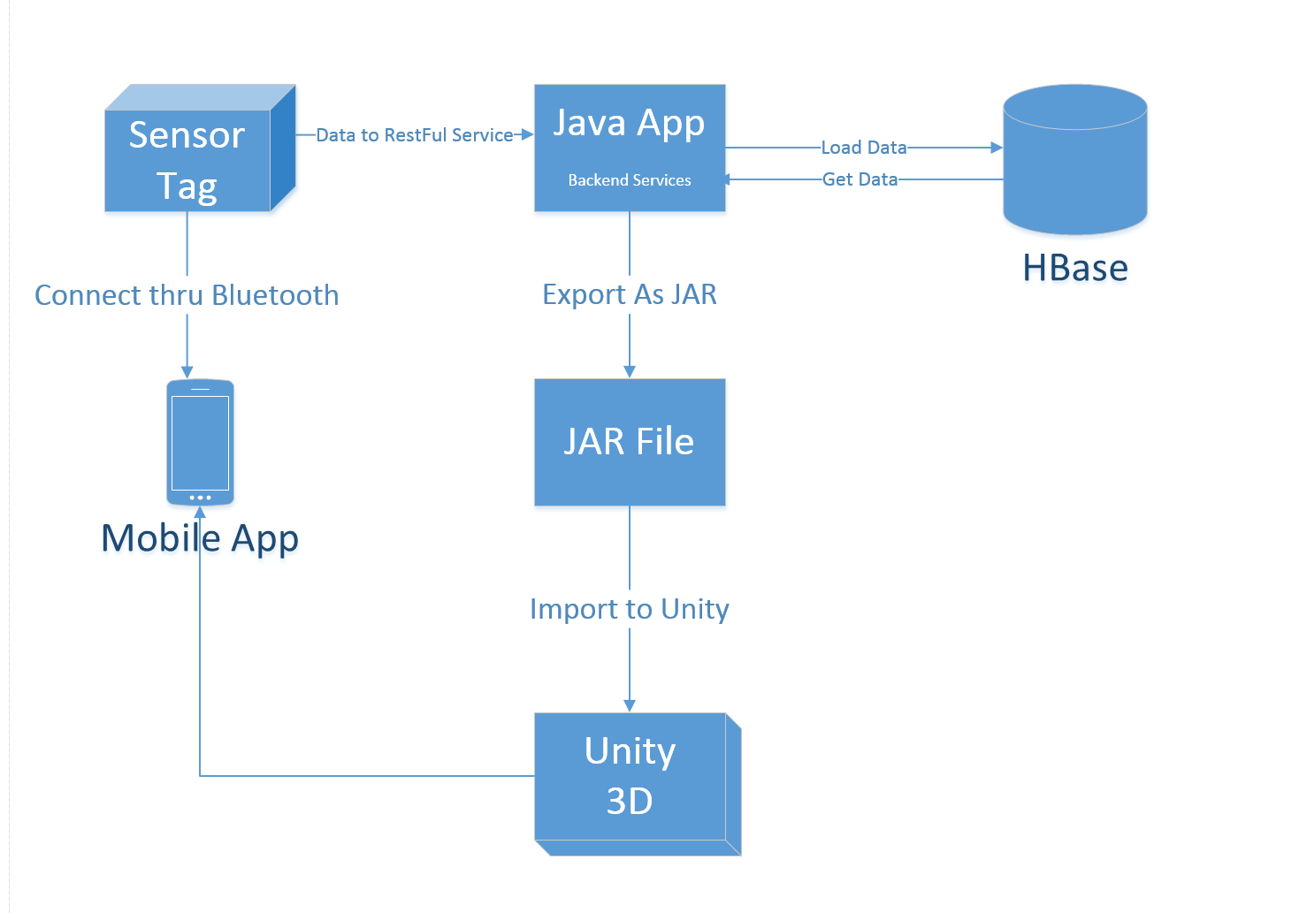

**Architecture Diagram**

# TI Sensor Tag

## System Requirements

* CC2541 TI Sensor Tag
* Android 4.3 and above OS
* Bluetooth 4.0 and above
* Hadoop and H Base
* Eclipse, Java, Android
* Data from sensor tag
* Unity 3D

## Device Configuration

Steps to be followed:

1. Open android SDK and create a new project with minimum android version to be 4.3
2. Use three classes in the project Main Activity, Connection Service, Sensor Tag Data
3. Update manifest File

<service android:name=*"com.example.test.ConnectionService"*></service>

1. Add these permissions in manifest to turn Bluetooth on Android mobile

<uses-permission android:name=*"android.permission.BLUETOOTH"*/>

<uses-permission android:name=*"android.permission.BLUETOOTH_ADMIN"*/>

<uses-feature android:name="android.hardware.bluetooth_le" android:required="true"/>

1. Add this in onCreate() method of Main Activity Class

startService(**new** Intent(MainActivity.**this**,ConnectionService.**class**));

1. Turn On Sensor Tag before launching the Application
2. Download an android app named “BLE SensorTag” to test your sensor

## Data Filtering/Peak Detection

1. Start Sensor Tag
2. Perform Gesture
3. Collect Sensor Data
4. Filter the Data where Peaks are detected with start and end tags

## HBase Data Push

1. Add this remote server address 134.193.136.127 to your host file
2. Use CRUD Operations to Create, Insert, Retrieve and Delete Tables in HBase
3. Create Column Families
4. Add sensor file path to insert method in the source code to load sensor data into HBase
5. Perform Retrieve function to cross check data availability
6. Delete if the data is not appropriate

# HMM

**Hidden Markov Model (A Statistical Markov Model):**

The conditional probability distribution of future states of the process depends only upon the present state.

In simpler [Markov models](http://en.wikipedia.org/wiki/Markov_model), the state is directly visible to the observer, and therefore the state transition probabilities are the only parameters. In a hidden Markov model, the state is not directly visible, but output, dependent on the state, is visible. Each state has a probability distribution over the possible output tokens. Therefore the sequence of tokens generated by an HMM gives some information about the sequence of states. Note that the adjective 'hidden' refers to the state sequence through which the model passes, not to the parameters of the model; the model is still referred to as a 'hidden' Markov model even if these parameters are known exactly.

## Training and Testing Data

File1:

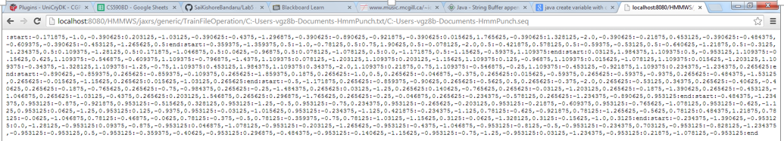

File2:

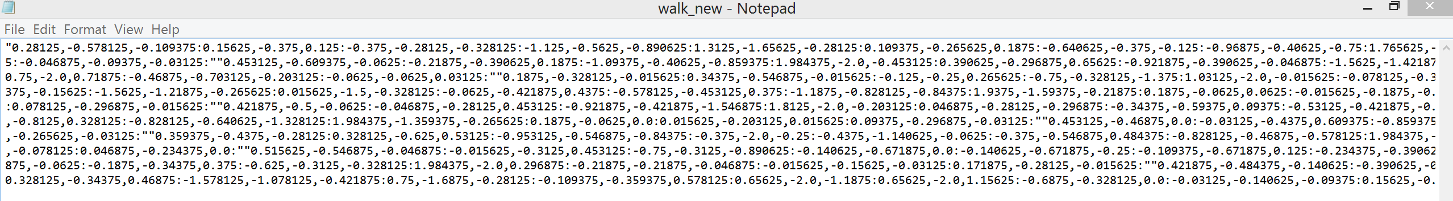

# Unity 3D

# Unity is made to empower you to create the best interactive entertainment or multimedia experience that you can. This manual is designed to help you learn how to use Unity, from basic to advanced techniques.

## Primitive Objects

Unity can work with 3D models of any shape that can be created with modelling software. However, there are also a number of primitive object types that can be created directly within Unity, namely the **Cube**, **Sphere**, **Capsule**, **Cylinder**, **Plane** and **Quad**. These objects are often useful in their own right (a plane is commonly used as a flat ground surface, for example) but they also offer a quick way to create placeholders and prototypes for testing purposes. Any of the primitives can be added to the scene using the appropriate item on the **GameObject > Create other** menu.

## Cube

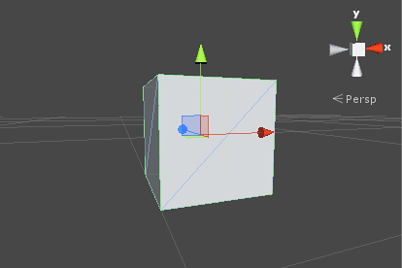

This is a simple cube with sides’ one unit long, textured so that the image is repeated on each of the six faces. As it stands, a cube isn’t really a very common object in most games but when scaled, it is very useful for walls, posts, boxes, steps and other similar items. It is also a handy placeholder object for programmers to use during development when a finished model is not yet available. For example, a car body can be crudely modelled using an elongated box of roughly the right dimensions. Although this is not suitable for the finished game, it is fine as a simple representative object for testing the car’s control code. Since a cube’s edges are one unit in length, you can check the proportions of a mesh imported into the scene by adding a cube close by and comparing the sizes.

## Sphere

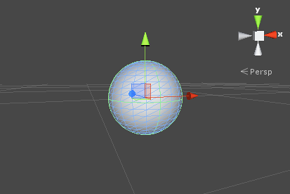

This is a sphere of unit diameter (0.5 unit radius), textured so that the entire image wraps around once with the top and bottom “pinched” at the poles. Spheres are obviously useful for representing balls, planets and projectiles but a semi-transparent sphere can also make a nice GUI device for representing the radius of an effect.

## Capsule

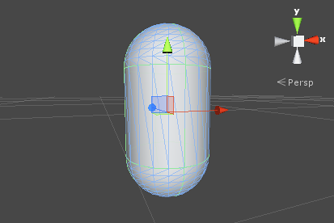

A capsule is a cylinder with hemispherical caps at the ends. The object is one unit in diameter and two units high (the body is one unit and the two caps are half a unit each). It is textured so that the image wraps around exactly once, pinched at each hemisphere’s apex. While there aren’t many real world objects with this shape, the capsule is a useful placeholder for prototyping. In particular, the physics of a rounded object are sometimes better than those of a box for certain tasks.

## Cylinder

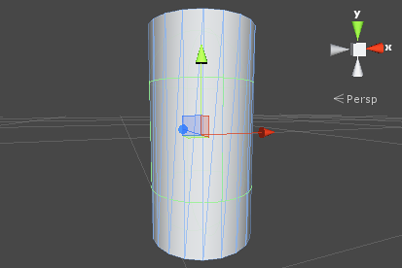

This is a simple cylinder which is two units high and one unit in diameter, textured so that the image wraps once around the tube shape of the body but also appears separately in the two flat, circular ends. Cylinders are very handy for creating posts, rods and wheels but you should note that the shape of the collider is actually a capsule (there is no primitive cylinder collider in Unity). You should create a mesh of the appropriate shape in a modelling program and attach a mesh collider if you need an accurate cylindrical collider for physics purposes.

## Plane

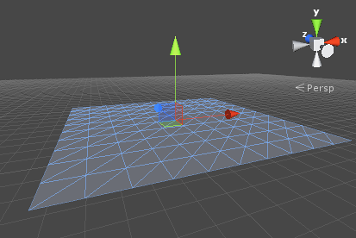

This is a flat square with edges ten units long oriented in the XZ plane of the local coordinate space. It is textured so that the whole image appears exactly once within the square. A plane is useful for most kinds of flat surface, such as floors and walls. A surface is also needed sometimes for showing images or movies in GUI and special effects. Although a plane can be used for things like this, the simpler **quad** primitive is often a more natural fit to the task.

## Quad

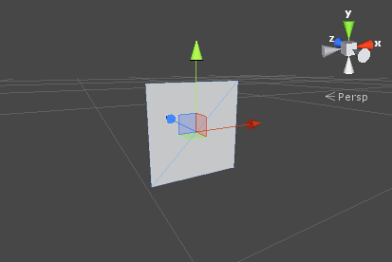

The quad primitive resembles the plane but its edges are only one unit long and the surface is oriented in the XY plane of the local coordinate space. Also, a quad is divided into just two triangles whereas the plane contains two hundred. A quad is useful in cases where a scene object must be used simply as a display screen for an image or movie. Simple GUI and information displays can be implemented with quads, as can particles, sprites and “impostor” images that substitute for solid objects viewed at a distance.

## Controlling Game Objects Using Components

In the Unity editor, you make changes to Component properties using the Inspector. So, for example, changes to the position values of the Transform Component will result in a change to the GameObject’s position. Similarly, you can change the color of a Renderer’s material or the mass of a Rigidbody with a corresponding effect on the appearance or behavior of the GameObject. For the most part, scripting is also about modifying Component properties to manipulate GameObjects.

## Accessing Components

The simplest and most common case is where a script needs access to other Components attached to the same GameObject. As mentioned in the Introduction section, a Component is actually an instance of a class so the first step is to get a reference to the Component instance you want to work with. This is done with the [GetComponent](http://docs.unity3d.com/ScriptReference/Component.GetComponent.html) function. Typically, you want to assign the Component object to a variable, which is done in C# using the following syntax:-

*void Start () {*

*Rigidbody rb = GetComponent<Rigidbody>();*

*}*

*In UnityScript, the syntax is subtly different:-*

*function Start () {*

*var rb = GetComponent.<Rigidbody>();*

*}*

Once you have a reference to a Component instance, you can set the values of its properties much as you would in the Inspector:-

*void Start () {*

*Rigidbody rb = GetComponent<Rigidbody>();*

*// Change the mass of the object's Rigidbody.*

*rb.mass = 10f;*

*}*

An extra feature that is not available in the Inspector is the possibility of calling functions on Component instances:-

*void Start () {*

*Rigidbody rb = GetComponent<Rigidbody>();*

*// Add a force to the Rigidbody.*

*rb.AddForce(Vector3.up * 10f);*

*}*

Note also that there is no reason why you can’t have more than one custom script attached to the same object. If you need to access one script from another, you can use GetComponent as usual and just use the name of the script class (or the filename) to specify the Component type you want.

If you attempt to retrieve a Component that hasn’t actually been added to the GameObject then GetComponent will return null; you will get a null reference error at runtime if you try to change any values on a null object.

Since some Component types are very commonly used, Unity provides built-in variables to access them in the MonoBehaviour class, so you can use things like:-

*void Start () {*

*transform.position = Vector3.zero;*

*}*

Without first having to use GetComponent to access the Transform Component. The full list of built-in Component variables is given in the MonoBehaviour script reference page. Note that as with GetComponent, if the desired Component isn’t attached to the object then the variable will contain a null value.

## Accessing Other Objects

Although they sometimes operate in isolation, it is common for scripts to keep track of other objects. For example, a pursuing enemy might need to know the position of the player. Unity provides a number of different ways to retrieve other objects, each appropriate to certain situations.

### **Linking Objects with Variables**

The most straightforward way to find a related GameObject is to add a public GameObject variable to the script:-

*public class Enemy : MonoBehaviour {*

*public GameObject player;*

*// Other variables and functions...*

*}*

You can now drag an object from the scene or Hierarchy panel onto this variable to assign it. The GetComponent function and Component access variables are available for this object as with any other, so you can use code like the following:-

*public class Enemy : MonoBehaviour {*

*public GameObject player;*

*void Start() {*

*// Start the enemy ten units behind the player character.*

*transform.position = player.transform.position - Vector3.forward * 10f;*

*}*

*}*

Additionally, if declare a public variable of a Component type in your script, you can drag any GameObject that has that Component attached onto it. This will access the Component directly rather than the GameObject itself.

public Transform playerTransform;

Linking objects together with variables is most useful when you are dealing with individual objects that have permanent connections. You can use an array variable to link several objects of the same type, but the connections must still be made in the Unity editor rather than at runtime. It is often convenient to locate objects at runtime and Unity provides two basic ways to do this, as described below.

### **Finding Child Objects**

Sometimes, a game scene will make use of a number of objects of the same type, such as enemies, waypoints and obstacles. These may need to be tracked by a particular script that supervises or reacts to them (eg, all waypoints may need to be available to a pathfinding script). Using variables to link these objects is a possibility but it will make the design process tedious if each new waypoint has to be dragged to a variable on a script. Likewise, if a waypoint is deleted then it is a nuisance to have to remove the variable reference to the missing object. In cases like this, it is often better to manage a set of objects by making them all children of one parent object. The child objects can be retreived using the parent’s Transform Component (since all GameObjects implicitly have a Transform):-

*public class WaypointManager : MonoBehaviour {*

*public Transform waypoints;*

*void Start() {*

*waypoints = new Transform[transform.childCount];*

*int i = 0;*

*for (Transform t in transform) {*

*waypoints[i++] = t;*

*}*

*}*

You can also locate a specific child object by name using the [Transform.Find](http://docs.unity3d.com/ScriptReference/Transform.Find.html) function:-

transform.Find("Gun");

This can be useful when an object has a child that can be added and removed during gameplay. A weapon that can be picked up and put down is a good example of this.

### **Finding Objects by Name or Tag**

It is always possible to locate GameObjects anywhere in the scene hierarchy as long as you have some information to identify them. Individual objects can be retrieved by name using the [GameObject.Find](http://docs.unity3d.com/ScriptReference/GameObject.Find.html) function:-

*GameObject player;*

*void Start() {*

*player = GameObject.Find("MainHeroCharacter");*

*}*

An object or a collection of objects can also be located by their tag using the [GameObject.FindWithTag](http://docs.unity3d.com/ScriptReference/GameObject.FindWithTag.html) and [GameObject.FindGameObjectsWithTag](http://docs.unity3d.com/ScriptReference/GameObject.FindGameObjectsWithTag.html)functions:-

*GameObject player;*

*GameObject[] enemies;*

*void Start() {*

*player = GameObject.FindWithTag("Player");*

*enemies = GameObject.FindGameObjectsWithTag("Enemy");*

*}*

# Integration

**Steps involved in Integrating Sensor data with Unity 3D:**

1. Create a JAR file
2. Update the Manifest File
3. Access components corresponding to activity recognition
4. Test each Activity

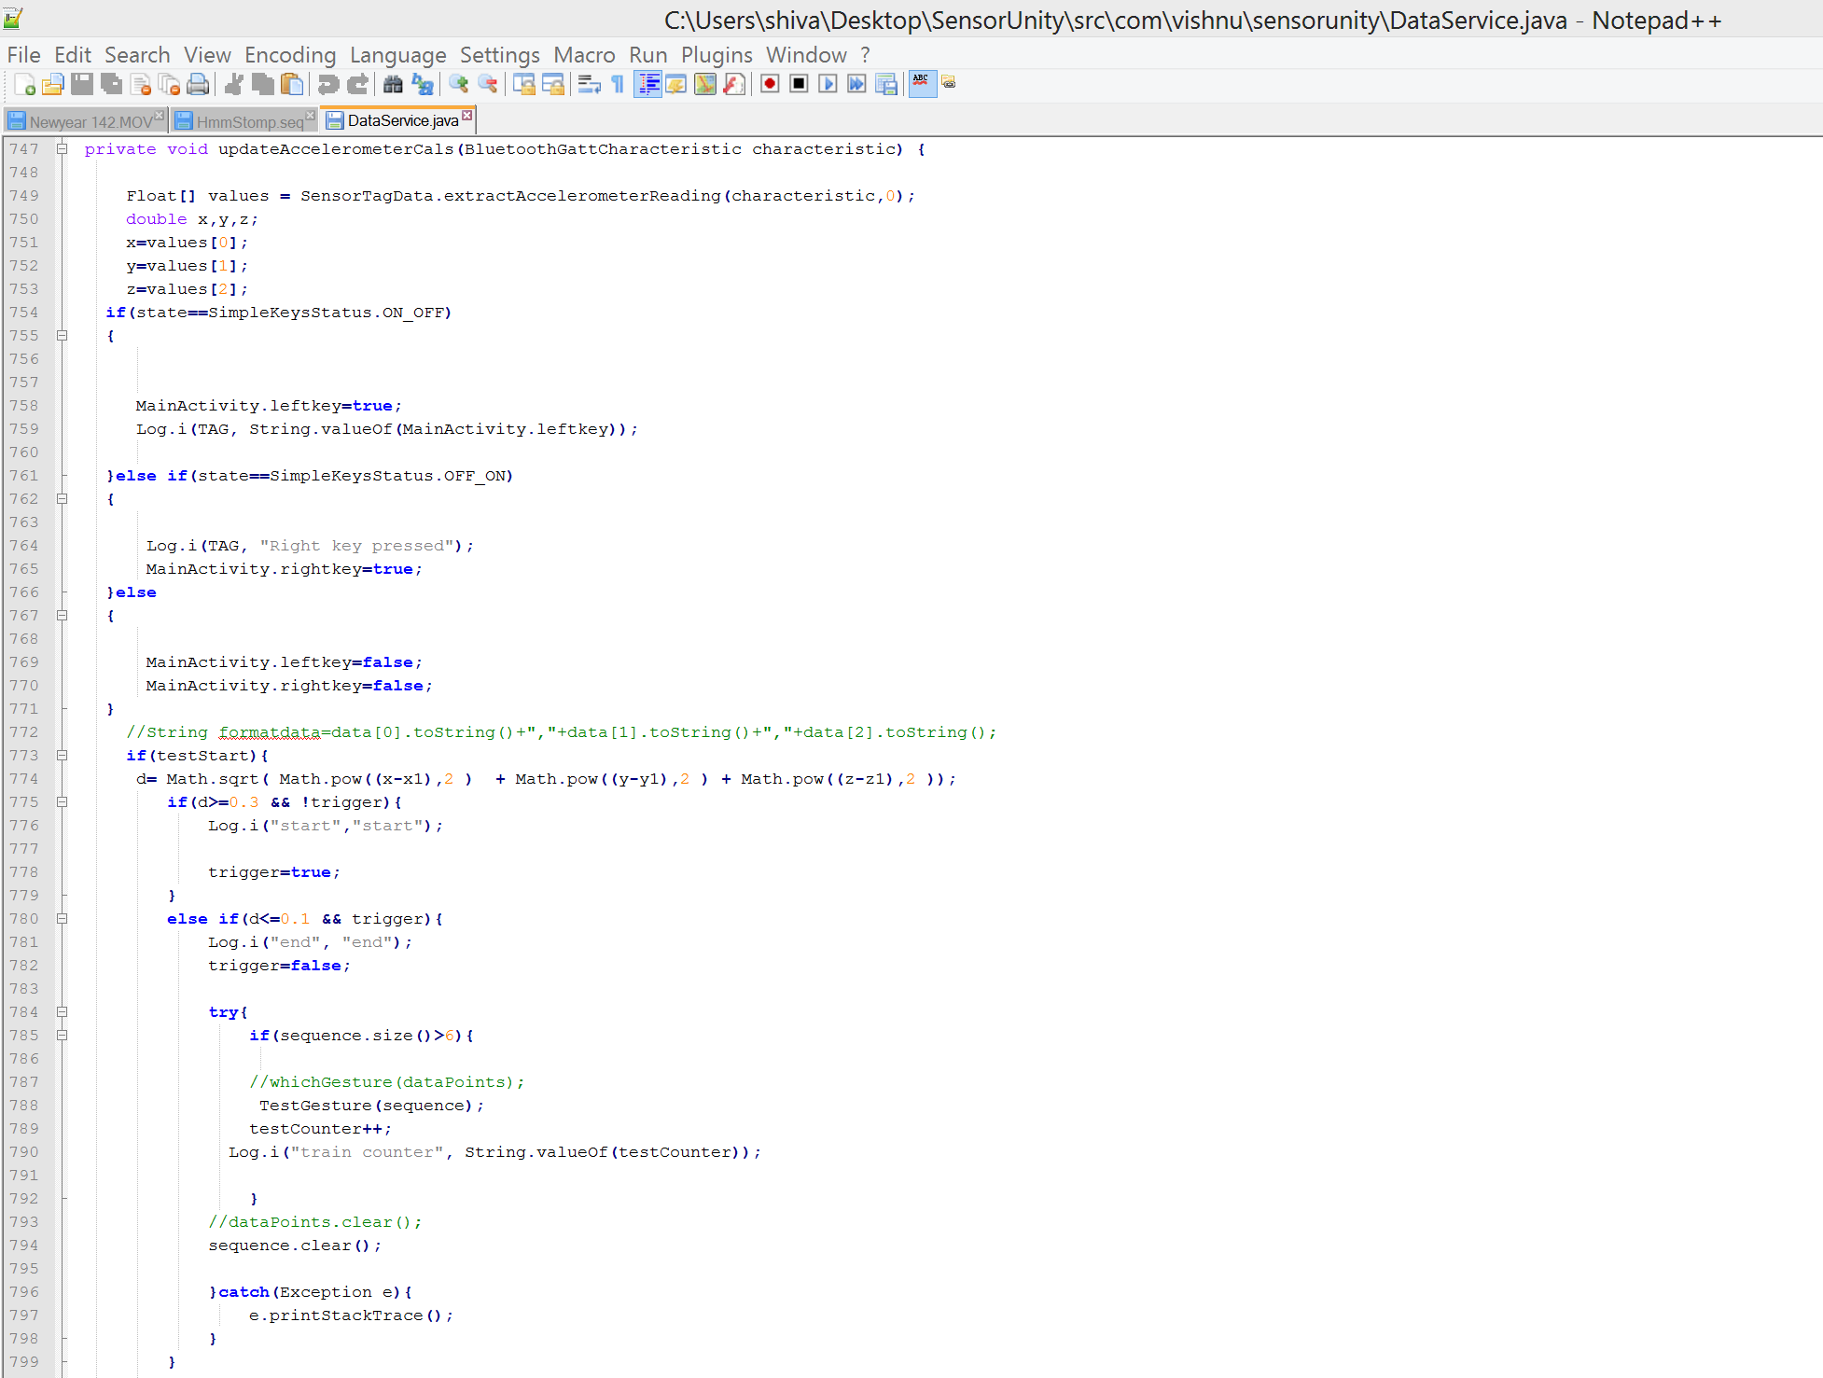

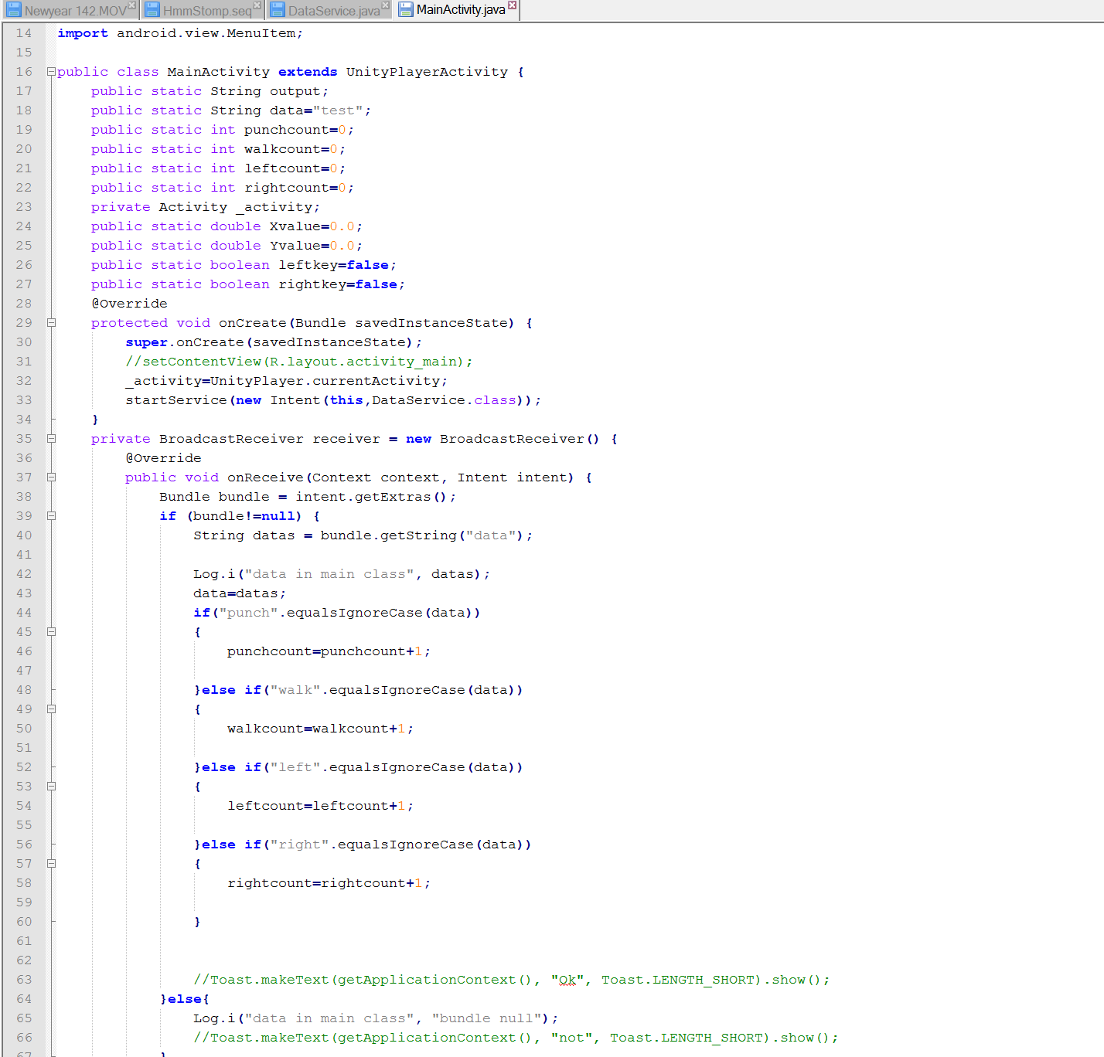

# Online Application

1. Designing 3D Objects

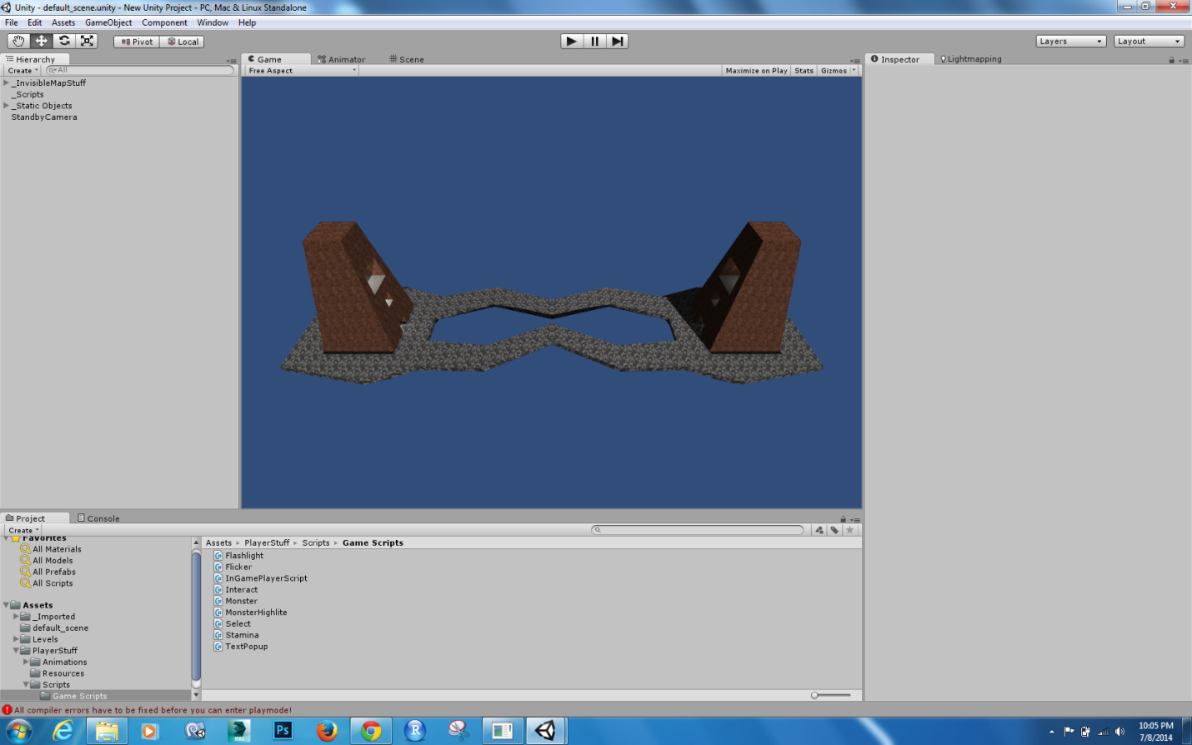

1. Actual Gaming Environment

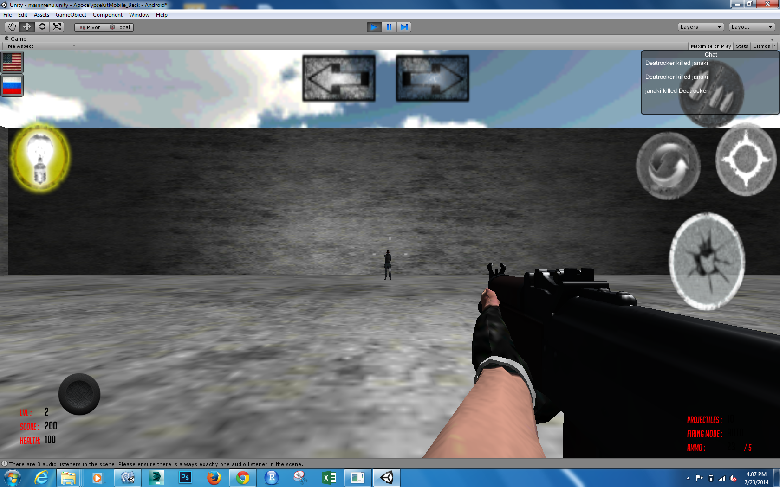

## Networking Protocols used in multiplayer environment

## RPC (Remote Procedure Calls):

An RPC is initiated by the client, which sends a request message to a known remote server to execute a specified procedure with supplied parameters. The remote server sends a response to the client, and the application continues its process. While the server is processing the call, the client is blocked, unless the client sends an asynchronous request to the server, such as an XHTTP call. There are many variations and subtleties in various implementations, resulting in a variety of different RPC protocols. An important difference between remote procedure calls and local calls is that remote calls can fail because of unpredictable network problems. Also, callers generally must deal with such failures without knowing whether the remote procedure was actually invoked. Idempotent procedures are easily handled, but enough difficulties remain that code to call remote procedures is often confined to carefully written low-level subsystems.

## Sequence of events during an RPC

1. The client calls the client stub. The call is a local procedure call, with parameters pushed on to the stack in the normal way.
2. The client stub packs the parameters into a message and makes a system call to send the message. Packing the parameters is called marshalling.
3. The client's local operating system sends the message from the client machine to the server machine.
4. The local operating system on the server machine passes the incoming packets to the server stub.
5. The server stub unpacks the parameters from the message. Unpacking the parameters is called un-marshalling.
6. Finally, the server stub calls the server procedure. The reply traces the same steps in the reverse direction.

# Offline System

**Steps involved in preparing Offline charts:**

1. Train sequence files through HMM
2. Push data to HBase
3. Pull Data from HBase and send it to High Charts
4. Generate Reports
5. **Number of Moves made**

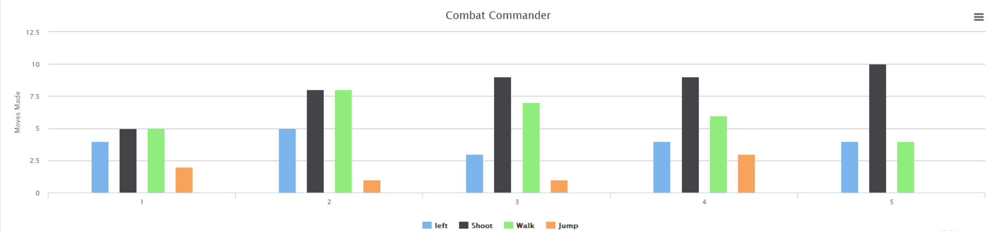

1. **Moves Share**

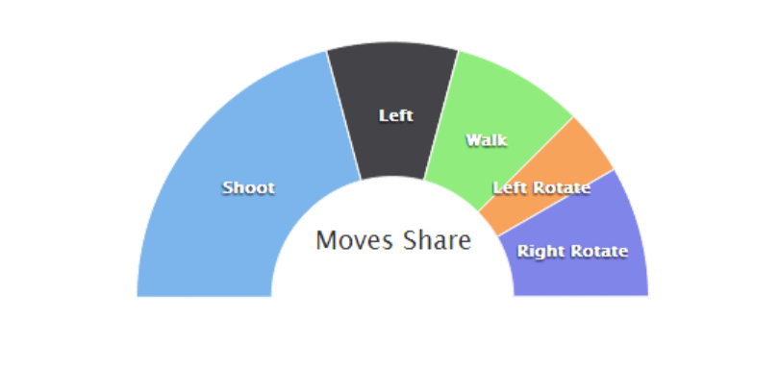

1. **Line Chart**

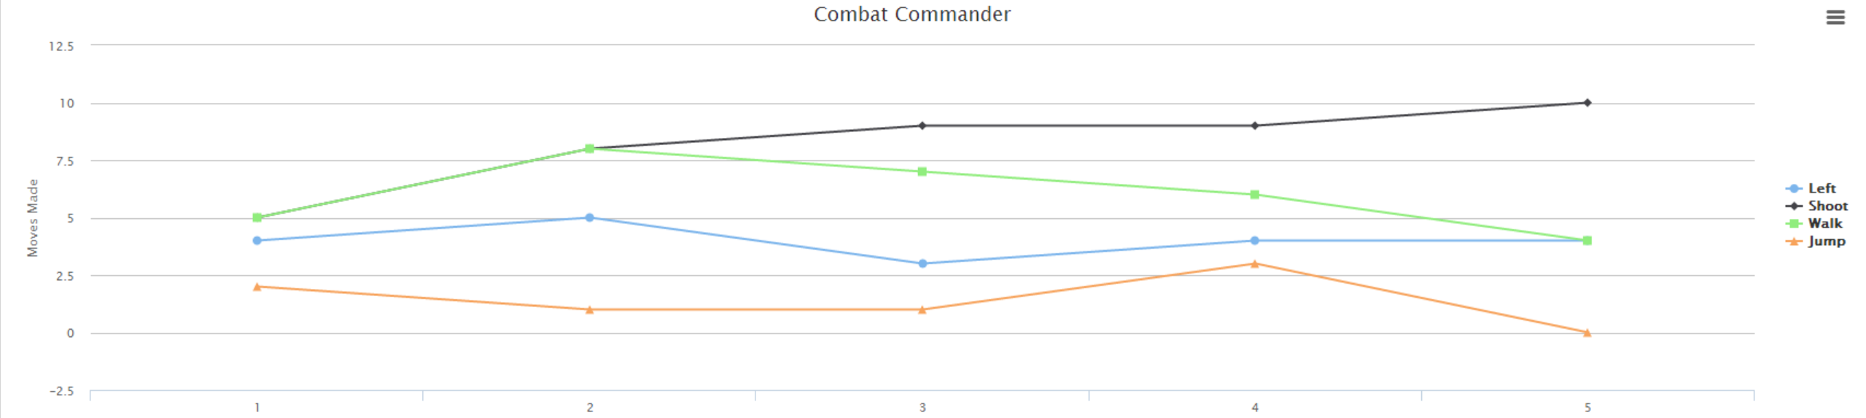

## Confusion Matrix

**Observations:**

|  |  |  |  |  |
| --- | --- | --- | --- | --- |
| Observations | Left | Right | Walk | Shoot |
| Left | 10 | 0 | 0 | 0 |
| Right | 0 | 10 | 0 | 0 |
| Walk | 0 | 0 | 10 | 0 |
| Shoot | 0 | 0 | 2 | 8 |

**Accuracy:**

|  |  |  |  |
| --- | --- | --- | --- |
| Accuracy | Precision | Recall | F-Measure |
| Left | 1 | 1 | 1 |
| Right | 1 | 1 | 1 |
| Walk | 0.833 | 1 | 0.908 |
| Shoot | 1 | 0.8 | 0.888 |

**Note:**

Overall accuracy: 95%

# Project deployment

**Project Deployment Link:**

[**https://github.com/shivapothala/BigData/tree/master/Project**](https://github.com/shivapothala/BigData/tree/master/Project)

## Project Video Link: <http://youtu.be/tH3MXTsYfVQ>

## Process and Workflows

This section Provides description of the overall process managed by the software, and how a user interacts with the system. It has different sub processes that user needs to navigate from one functionality to the other. Please see below workflows to better understand this.

**Device Constraints:**

## System Requirements:

* CC2541 TI Sensor Tag
* Android 4.3 and above OS
* Bluetooth 4.0 and above

**Design Choice:**

User need to have Unity 3D plugin installed and User should able to operate TI sensor tags with appropriate hand gestures.

* Left->Move left
* Up-> Move Right
* Stomp->Walk
* Punch->Shoot

# 

## Work Flows

## Process/Workflow1: Multiplayer Shooting Game

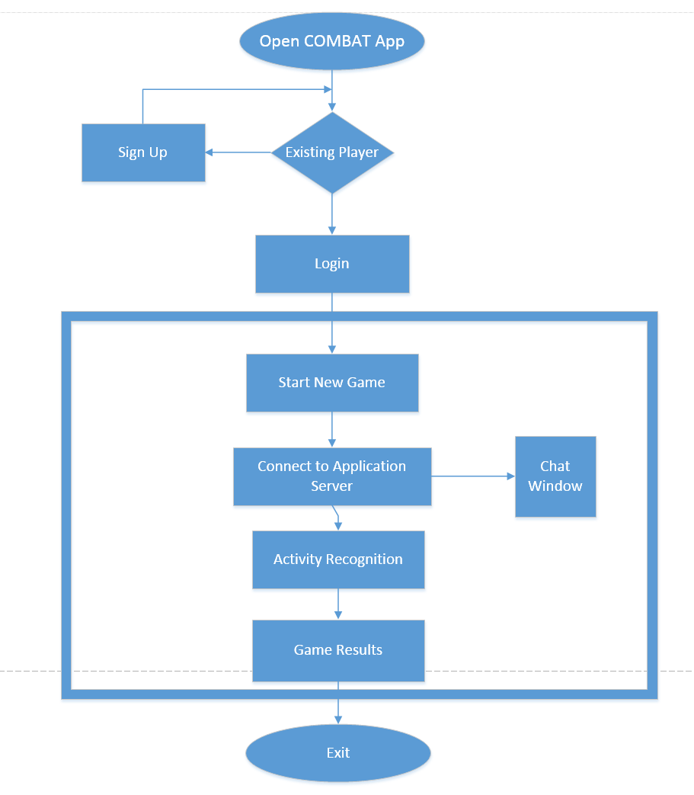

# User Manual

## User Interface

## 1) Login to App

## 

**2) Click on Start and connect to the Server**

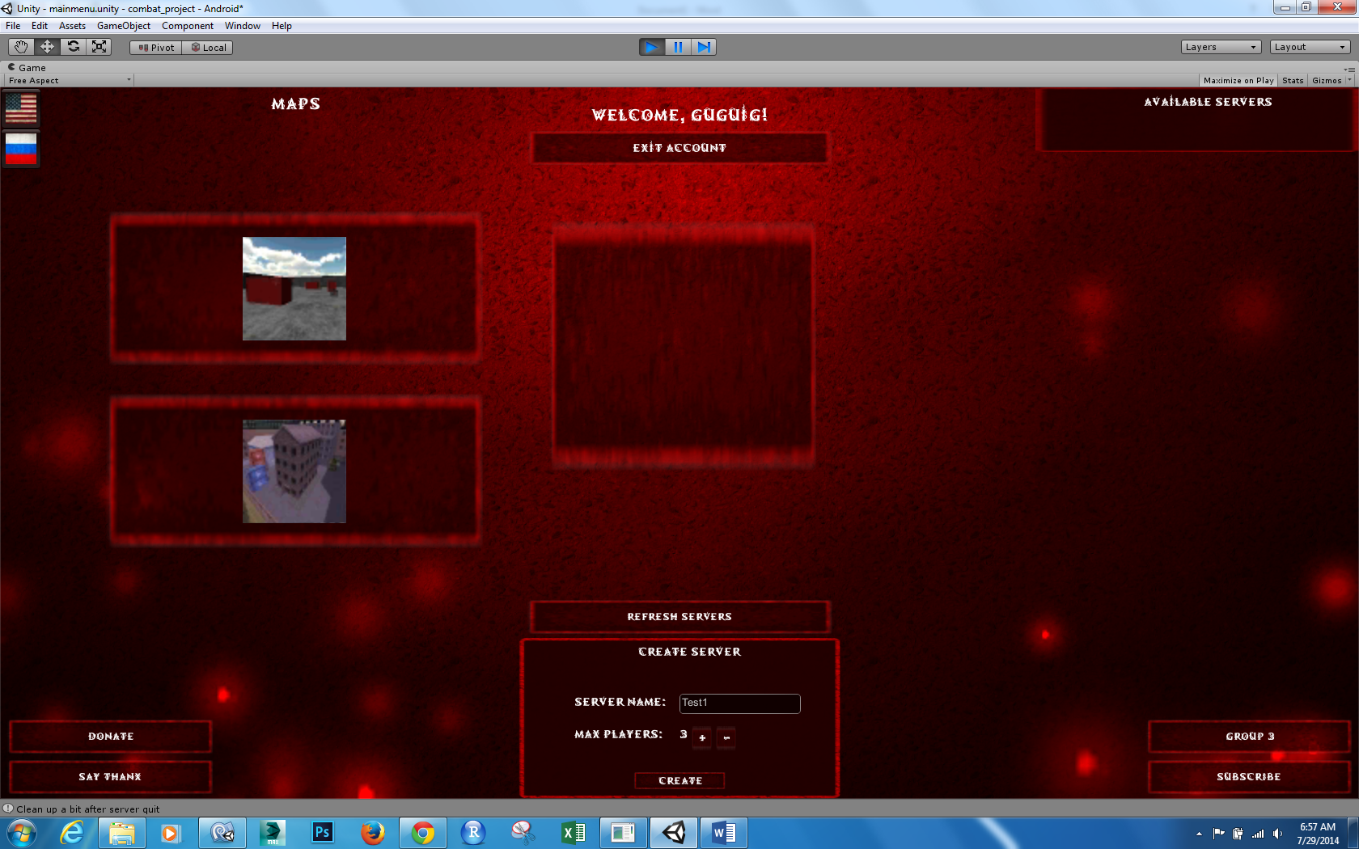

**3) Hand Gestures Left, Stomp, Up, Punch Respectively.**

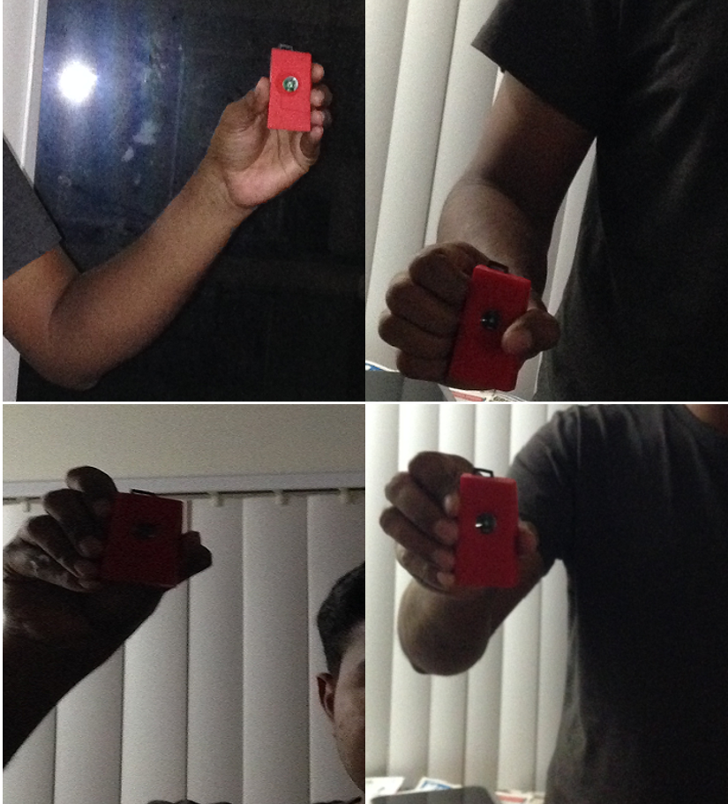

**4) Operate SensorTag and shoot other players**

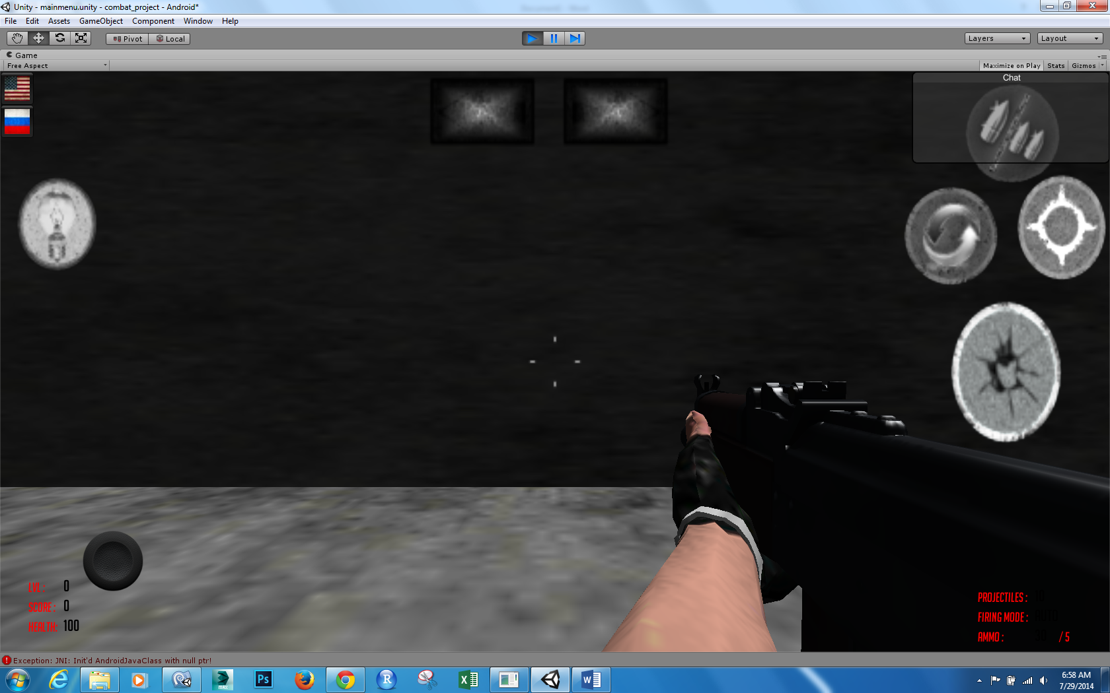

**5) Below screenshot shows Aiming and Shooting**



## Error Handling

1. Error when deploying JAR file in Unity 3D

* Resolved by modifying manifest file

1. Delay in response when Training HMM files

* Resolved by eliminating sequence files and directly loading dynamic values to the application

1. Inaccurate Gesture recognition

* Resolved by improving the accuracy of the gestures

## Uniqueness

1. **Response Time:** Best response time with less than a second when recognizing the activity
2. **Accuracy:** Overall Accuracy is about 95% with half of the activities are shown 100% accuracy
3. **Unity Features:** The best visual 3D terrains, characters and textures for user attractive environment

# Project Management

## Scrum Do

Scrum is a process management tool using agile software development framework designed for making the implementation of the software projects, products and applications easier. This mainly focus on "a flexible, holistic product development strategy where a team of developers would work as a unit to achieve a common task" which is contrast to a regular routine approach.

It also enables for the creation of self-organizing teams by encouraging co-location of all team members, and verbal communication among all team members and disciplines in the project.

**COMBAT Project Scrum Do Link:** [**https://www.scrumdo.com/projects/project/combat/summary**](https://www.scrumdo.com/projects/project/combat/summary)

**Increment 1(06/10/14 – 06/20/14):**

**Story:** As a team we want to collect data from sensor motion and filter the data.

**Increment 2(06/21/14 – 06/30/14):**

**Story**: As a team we want to train and test the data collected from sensor tags

**Increment 3(07/01/14 – 07/11/14):**

**Story**: As a team we want to design 3d unity objects and textures for gaming environment!!

**Increment 4(07/12/14 – 07/28/14):**

**Story:**  As a team we want to integrate our sensor data with Unity environment!!

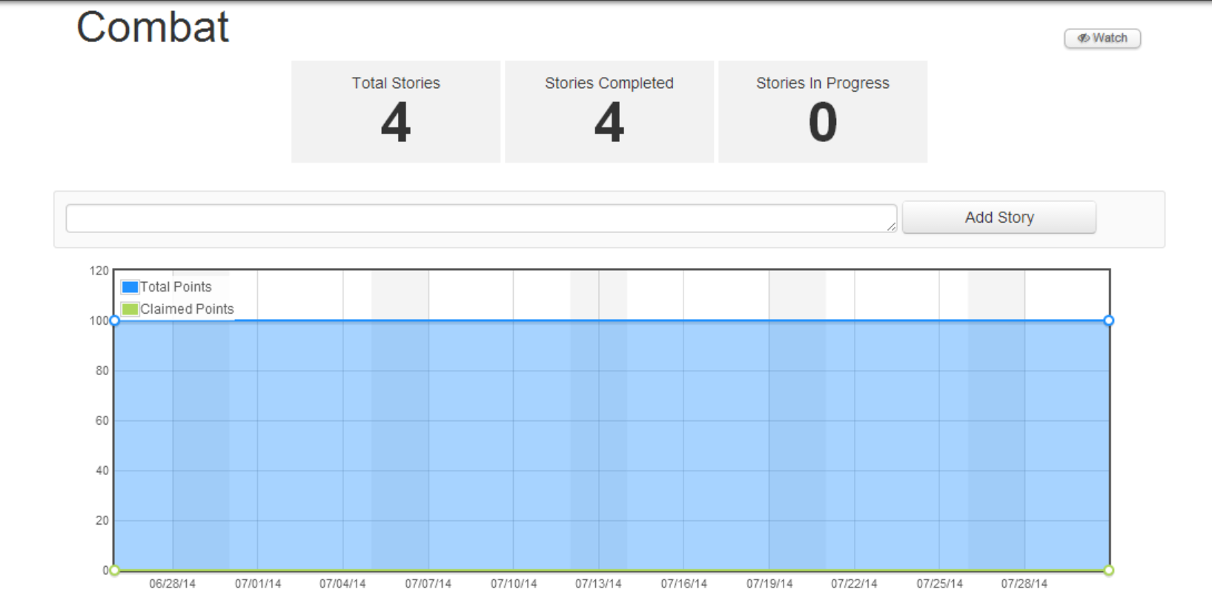

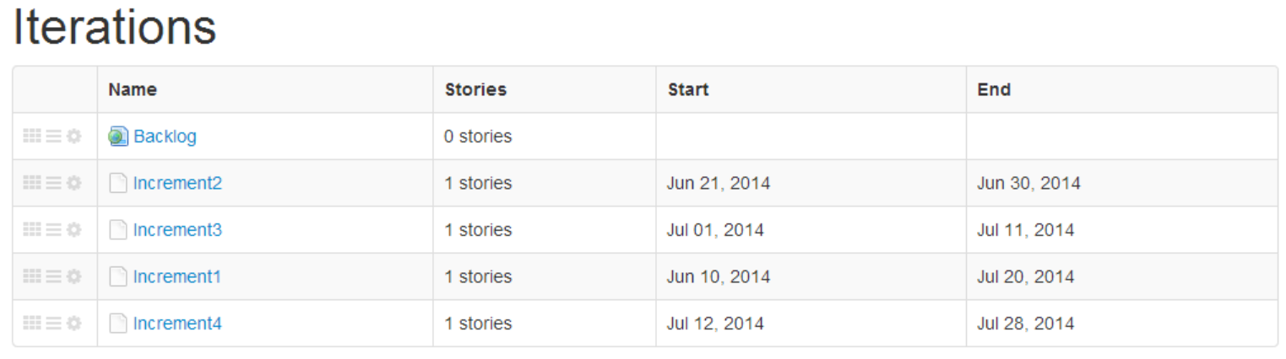

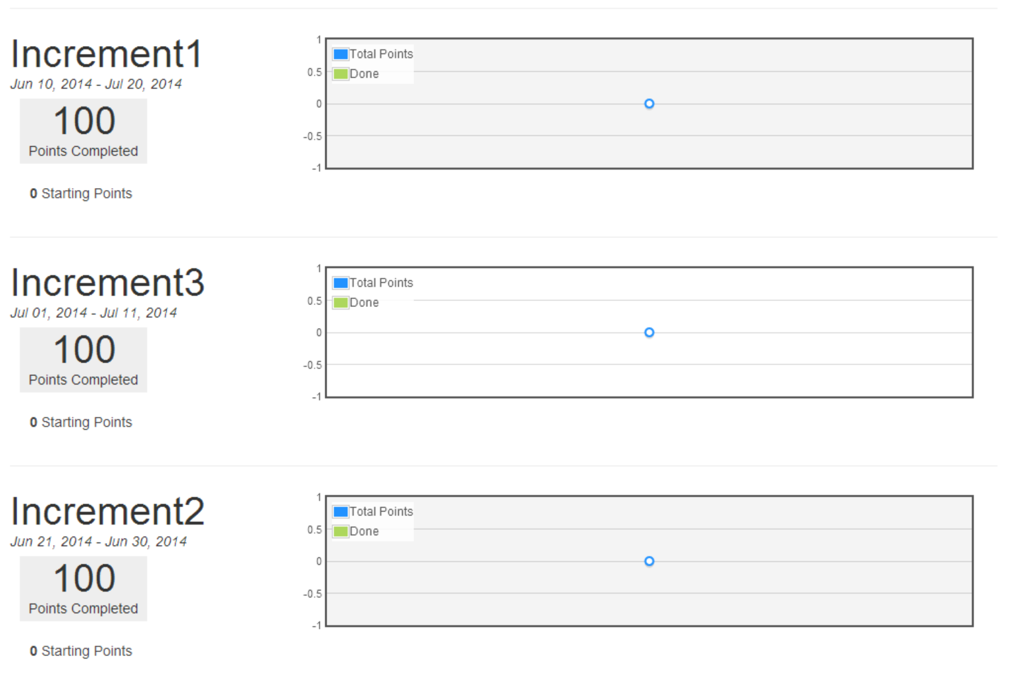

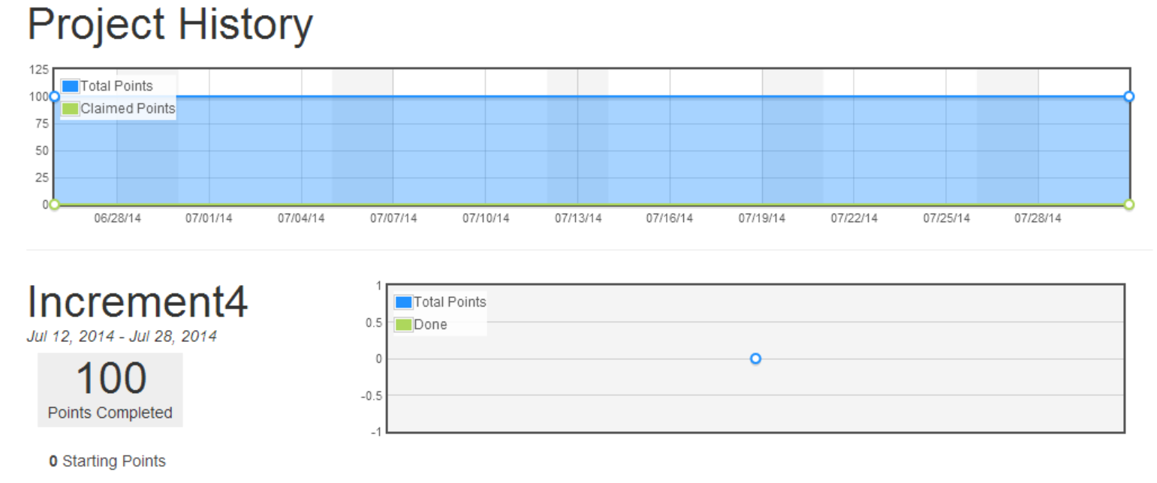

## Final Project Evaluation

* ***Discuss how well your project satisfies your original requirement specifications?***
* The project satisfies all the initial requirements mentioned in the proposal document.
* ***Were you satisfied with your design process?***
* Yes, the design process is well planned and organized so that it meets the real world project standards.
* ***How helpful was the agile process?***
* Agile process was helpful in planning the development of the entire project, tracking of the pending stories, estimating the expected end date of project.
* ***How would you do the agile process next time?***
* We stick to the agile standards and try to be more effective in terms of schedules and plans. Monitoring the project throughout its life cycle made easy with this.

* ***Did you stick to your project plan schedule?***
* Yes, we have planned as per the increments and followed it in the project development.
* ***What was the real management structure within your group?***
* Yes, there were some issues in the initial stage, we were able to overcome through practice and effective learning.

* ***Does it bear any resemblance to structure that you had planned?***

Yes, it is similar to that of what we have planned.

* ***Did you have any problems getting each member to do his/her share of the work?***
* There are no issues with assigning tasks to the team member because of the agile structure we followed.
* ***Do you have any suggestion on how this could have been handled better?***
* Agile process would be more effective if it can be able to track the Service Level Agreement breaches of each task.
* ***Discuss what you might have done differently if this were a real world project? Any recommendations for next year?***
* Though course work is limited when compared to real world projects, we would like extend our plans to analyze real time datasets coming from most sensitive and trending applications like E-commerce, Health, and Energy Resource Apps.

# Increments

# First Increment

## Introduction

Advancements in the today's mobile technology created a huge scope to develop all kinds of user interactive applications. Multi player mobile games are more popular and fun to design by using motion sensor devices. This game allows multiple users to play and shoot each other and also it tracks user movements and acts according user simulation in the application.

## Project Goal and Objectives

* **Motivation**

The main motivation of this project comes from popularity of mobile games everywhere. From our childhood playing a game with friends always fun and we dreamt to have our own 3D game that everybody can play with our creatures and other 3D effects. After knowing about Sensor Tags and other user motion detective devices, we found a scope to develop this amazing application.

* **Objectives**

This collects data from different users through sensor tags and acts according to user motion in the shooting game. This would also rates a user in the game by giving performance based score. This kind of applications are designed to provide entertainment to users and show them how sensor tags can track their motion when they play around.

* **Significance**

There are plenty of mobile games available and this just one among them. But we are trying add few more features to it. This can be played on android or windows supporting devices like mobile phones or Tablets. With the animated 3D features user can have live play feeling when operating sensor tags.

## System Requirements:

* CC2541 TI Sensor Tag
* Android 4.3 and above OS
* Bluetooth 4.0 and above

## Technological and Architectural Requirements:

* Hadoop and HBase
* Eclipse, Java, Android, Windows
* Data from sensor tag
* Unity 3D

## Activity Recognition Scenario and Data Collection:



* **Devices/Sensors :**
* Android application
* Application using eclipse android ADT IDE
* Testing on Samsung Galaxy S4
* TI CC2541 Sensor Tag Development Kit
* temperature,
* humidity,
* pressure,
* accelerometer,
* gyroscope,
* Magnetometer.
* Using accelerometer, gyroscope and magnetometer
* Bluetooth connection with the device and transfers information
* **Data Collection**
* User movements as input from Sensor Tag
* HBase as Database
* Create a JAR file
* JAR file linked each user model
* Each User model integrated with mobile application to produce game environment
* Unity 3D framework to simulate user models
* **Motion/Activity Model**
* Android OS device with Bluetooth, to run application and a sensor tag.
* Sensor tag will be attached to each user
* User operates sensor tag
* Data is collected from sensor tag
* Shooting triggers based on User action
* Score will be given to each user
* **Analytical Tasks**
* Analytical task include
* Detection of users motion pattern
* User models transformed to game environment
* Shooting triggered based user motion simulation

## Design of Mobile Client:

Developing Android mobile app and Unity animations and integrating them.

**Features:**

* Android or windows devices allowed to download this application
* multiple user models and components created
* This is an open source Web kit
* It is an amazing 3D application based Unity Framework

## Related Work:

**Combat Trigger: Modern Dead 3D**

It is a war game where user can select different weapons and fight in different battle fields.

**Features included:**

Exciting campaign with plenty of battles, futuristic weapon, big bang grenades, armor and health customization, millions of enemies to kill, exotic planets and fallen human cities to fight in, battlefields on exotic planets, combat in fallen human cities

## Second Increment

## Introduction

Advancements in the today's mobile technology created a huge scope to develop all kinds of user interactive applications. Multi player mobile games are more popular and fun to design by using motion sensor devices. This game allows multiple users to play and shoot each other and also it tracks user movements and acts according user simulation in the application.

## Project Goal and Objectives

* **Motivation**

The main motivation of this project comes from popularity of mobile games everywhere. From our childhood playing a game with friends always fun and we dreamt to have our own 3D game that everybody can play with our creatures and other 3D effects. After knowing about Sensor Tags and other user motion detective devices, we found a scope to develop this amazing application.

* **Objectives**

This collects data from different users through sensor tags and acts according to user motion in the shooting game. This would also rates a user in the game by giving performance based score. This kind of applications are designed to provide entertainment to users and show them how sensor tags can track their motion when they play around.

* **Significance**

There are plenty of mobile games available and this just one among them. But we are trying add few more features to it. This can be played on android or windows supporting devices like mobile phones or Tablets. With the animated 3D features user can have live play feeling when operating sensor tags.

## System Features:

* **Activity Models:**

Four hand gestures Left, Up, Stomp, and Punch are used for determining Left, Right, walk and Punch activities. Our offline part is to generate sequence files for the trained data. Here each hand gesture is trained with ten samples. Now these data has been trained and the respective sequence files have been generated for each and every hand gesture.

* **Motion Models:**

We basically have four hand gestures to detect. Since we already have sequence files of the trained data. Now the new gesture data will be collected using the sensor tag and then a sequence file will be generated for these data. Now these sequence file will be compared with the trained sequence files and the appropriate gesture is detected.

## System Requirements:

* CC2541 TI Sensor Tag
* Android 4.3 and above OS
* Bluetooth 4.0 and above

## Technological and Architectural Requirements:

* Hadoop, H Base
* Eclipse, Java, Android
* Data from sensor tag
* Unity 3D

## Activity Recognition Scenario and Data Collection:



## Data Collection:

1. Data collected for the Left Gesture

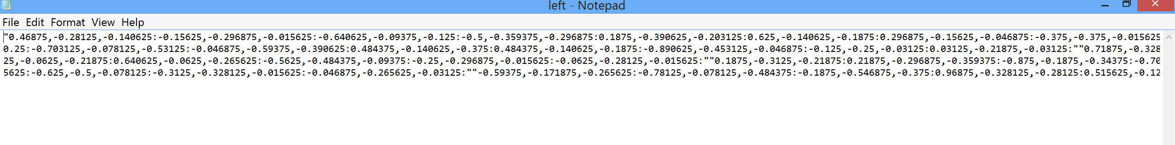

1. Data collected for the Right Gesture

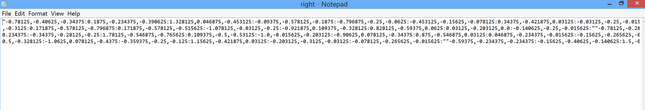

1. Data collected for the Walk (Stomp) Gesture



1. Data collected for the Stomp Gesture

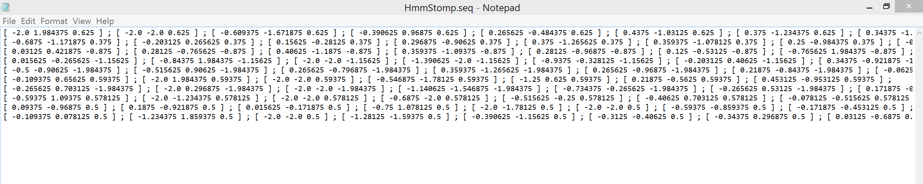

1. Data collected for the Punch(Shoot) Gesture

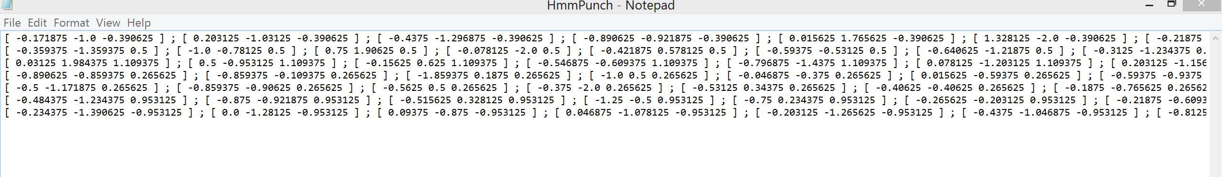

## Related Work:

**Combat Trigger: Modern Dead 3D**

It is a war game where user can select different weapons and fight in different battle fields.

**Features included:**

Exciting campaign with plenty of battles, futuristic weapon, big bang grenades, armor and health customization, millions of enemies to kill, exotic planets and fallen human cities to fight in, battlefields on exotic planets, combat in fallen human cities

## Bibliography:

<https://play.google.com/store/apps/details?id=com.thunderbull_entertainment.callofdead&hl=en><https://play.google.com/store/apps/details?id=com.csshooter.roadshoot&hl=en>

<https://play.google.com/store/apps/details?id=com.fungame.wars&hl=en>

<https://play.google.com/store/apps/details?id=com.dseffects.StreetCombat&hl=en>

<https://play.google.com/store/apps/details?id=com.rubicon.dev.combatmonsters&hl=en>

## Third Increment

## Introduction

Advancements in the today's mobile technology created a huge scope to develop all kinds of user interactive applications. Multi player mobile games are more popular and fun to design by using motion sensor devices. This game allows multiple users to play and shoot each other and also it tracks user movements and acts according user simulation in the application.

## Project Goal and Objectives

* **Motivation**

The main motivation of this project comes from popularity of mobile games everywhere. From our childhood playing a game with friends always fun and we dreamt to have our own 3D game that everybody can play with our creatures and other 3D effects. After knowing about Sensor Tags and other user motion detective devices, we found a scope to develop this amazing application.

* **Objectives**

This collects data from different users through sensor tags and acts according to user motion in the shooting game. This would also rates a user in the game by giving performance based score. This kind of applications are designed to provide entertainment to users and show them how sensor tags can track their motion when they play around.

* **Significance**

There are plenty of mobile games available and this just one among them. But we are trying add few more features to it. This can be played on android or windows supporting devices like mobile phones or Tablets. With the animated 3D features user can have live play feeling when operating sensor tags.

## System Features:

* **Activity Models:**

Four hand gestures Left, Up, Stomp, and Punch are used for determining Left, Right, walk and Punch activities. Our offline part is to generate sequence files for the trained data. Here each hand gesture is trained with ten samples. Now these data has been trained and the respective sequence files have been generated for each and every hand gesture.

* **Motion Models:**

We basically have four hand gestures to detect. Since we already have sequence files of the trained data. Now the new gesture data will be collected using the sensor tag and then a sequence file will be generated for these data. Now these sequence file will be compared with the trained sequence files and the appropriate gesture is detected.

## System Requirements:

* CC2541 TI Sensor Tag
* Android 4.3 and above OS
* Bluetooth 4.0 and above

## Technological and Architectural Requirements:

* Hadoop, H Base
* Eclipse, Java, Android
* Data from sensor tag
* Unity 3D

## Activity Recognition Scenario and Data Collection:



## Offline Application: Activity Report

**Devices/Sensors:**

Devices which we have used for our emotion detection application are:

* Android mobile device
* Sensor Tag

The sensor tag here we used is a product of Texas Instruments.

**Motion Models:**

We used four hand gestures to detect. Since we already have sequence files of the trained data. Now the new gesture data will be collected using the sensor tag and then a sequence file will be generated for these data. Now these sequence file will be compared with the trained sequence files and the appropriate gesture is detected.

1. Left Hand gesture is represented as Left
2. Right Hand gesture is represented as Right
3. Stomp hand gesture is represented as Walk
4. Punch hand gesture is represented as Shoot

**Application Features:**

Multiple players can join the application server and play shooting each other. Each Player has to shoot thrice (three times) the other player to kill him/her. These application is basically designed for the Android users and the support will be provided starting from SDK version 18 till SDK version 19. Users have to install Unity 3D plugin to load 3D gaming environment. Here overall accuracy of sensor motion is recorded as 95%.

**Recognition/ Analysis Approaches:**

As mentioned earlier in our application we have used the K-NN logic and also HMM model for the detection of hand gestures. Using already prepared sequence files our application works efficiently with minimum time delay of less than one sec. Now in our application on the foreground we will first detect the hand gesture. This will be done by using two buttons namely “Start recognition” and “End recognition” which indicates the start and end of hand gesture respectively. The detect motion has two important methods

* Train()
* Test()

In the train function first we shall take the trained sequence files and train the application. Now once we have the trained results, which will be stored internally in the cache by the K-NN algorithm, we shall take the currently tapped sequence file data and map them to the trained results so as to detect the emotion.

**Evaluation: Motion/Activity Recognition**

**Number of Users:**

The data has been collected from five users and each user will be making five samples of actions for each gesture.

**Types of Motion/Activities:**

We have typically used four gestures in our application to detect different motions. The four gestures which we use for detection are:

1. Left Hand gesture is represented as Left move
2. Up Hand gesture is represented as Right move
3. Stomp hand gesture is represented as Walk
4. Punch hand gesture is represented as Shoot

**Size of Data/Number of Gestures:**

The size of data for each trained gesture is found to be around 25 KB based on the gesture. But each training file has a huge number of values which are found be good enough for detecting the activities.

**Data Preparation:**

The data has been collected using the sensor tags. And after recording of each gesture we will be using these files for machine learning to generate the sequence files. The following are the snapshots of the respective data collected for one kind of gestures.

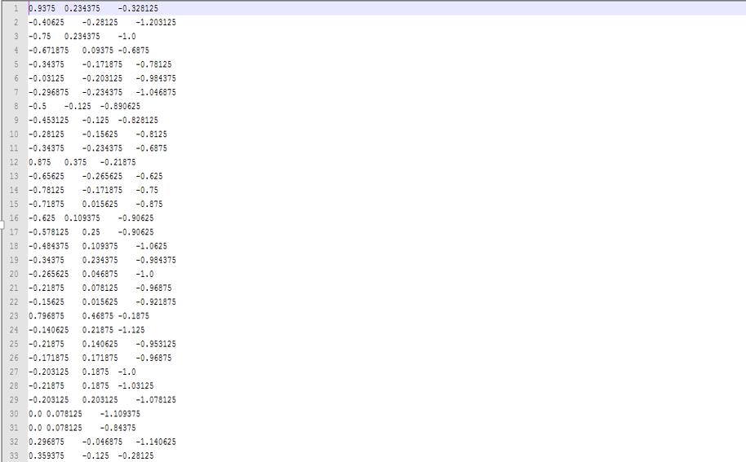

Sequence files:

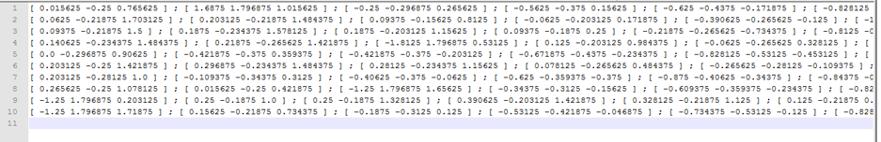

**Reports generated:**

**Steps involved in preparing Offline charts:**

1. Train sequence files through HMM
2. Push data to HBase
3. Pull Data from HBase and send it to High Charts
4. Generate Reports
5. **Number of Moves made**



1. **Moves Share**



1. **Line Chart**



**Confusion Matrix:**

Accuracy has been calculated using trained data collected from sequence files for all sensor motions left, right, stomp, and punch. We have seen 100% accuracy for Left and Right motions whereas for walk it is 91% and for shoot is 89%.

**Observations:**

|  |  |  |  |  |
| --- | --- | --- | --- | --- |
| Observations | Left | Right | Walk | Shoot |
| Left | 10 | 0 | 0 | 0 |
| Right | 0 | 10 | 0 | 0 |
| Walk | 0 | 0 | 10 | 0 |
| Shoot | 0 | 0 | 2 | 8 |

**Accuracy:**

|  |  |  |  |
| --- | --- | --- | --- |
| Accuracy | Precision | Recall | F-Measure |
| Left | 1 | 1 | 1 |
| Right | 1 | 1 | 1 |
| Walk | 0.833 | 1 | 0.908 |
| Shoot | 1 | 0.8 | 0.888 |

**Limitations:**

Amount rotations made by each player may not be accurate if the sensor tag is not moved properly.

## Related Work:

**Combat Trigger: Modern Dead 3D**

It is a war game where user can select different weapons and fight in different battle fields.

**Features included:**

Exciting campaign with plenty of battles, futuristic weapon, big bang grenades, armor and health customization, millions of enemies to kill, exotic planets and fallen human cities to fight in, battlefields on exotic planets, combat in fallen human cities

## Bibliography:

<https://play.google.com/store/apps/details?id=com.thunderbull_entertainment.callofdead&hl=en><https://play.google.com/store/apps/details?id=com.csshooter.roadshoot&hl=en>

<https://play.google.com/store/apps/details?id=com.fungame.wars&hl=en>

<https://play.google.com/store/apps/details?id=com.dseffects.StreetCombat&hl=en>

<https://play.google.com/store/apps/details?id=com.rubicon.dev.combatmonsters&hl=en>

## Fourth Increment

## Introduction

Advancements in the today's mobile technology created a huge scope to develop all kinds of user interactive applications. Multi player mobile games are more popular and fun to design by using motion sensor devices. This game allows multiple users to play and shoot each other and also it tracks user movements and acts according user simulation in the application.

## Project Goal and Objectives

* **Motivation**

The main motivation of this project comes from popularity of mobile games everywhere. From our childhood playing a game with friends always fun and we dreamt to have our own 3D game that everybody can play with our creatures and other 3D effects. After knowing about Sensor Tags and other user motion detective devices, we found a scope to develop this amazing application.

* **Objectives**

This collects data from different users through sensor tags and acts according to user motion in the shooting game. This would also rates a user in the game by giving performance based score. This kind of applications are designed to provide entertainment to users and show them how sensor tags can track their motion when they play around.

* **Significance**

There are plenty of mobile games available and this just one among them. But we are trying add few more features to it. This can be played on android or windows supporting devices like mobile phones or Tablets. With the animated 3D features user can have live play feeling when operating sensor tags.

## System Features:

* **Activity Models:**

Four hand gestures Left, Up, Stomp, and Punch are used for determining Left, Right, walk and Punch activities. Our offline part is to generate sequence files for the trained data. Here each hand gesture is trained with ten samples. Now these data has been trained and the respective sequence files have been generated for each and every hand gesture.

* **Motion Models:**

We basically have four hand gestures to detect. Since we already have sequence files of the trained data. Now the new gesture data will be collected using the sensor tag and then a sequence file will be generated for these data. Now these sequence file will be compared with the trained sequence files and the appropriate gesture is detected.

## System Requirements:

* CC2541 TI Sensor Tag
* Android 4.3 and above OS
* Bluetooth 4.0 and above

## Technological and Architectural Requirements:

* Hadoop, H Base
* Eclipse, Java, Android
* Data from sensor tag
* Unity 3D

## Activity Recognition Scenario and Data Collection:



## Online Application: Application by Motion

**Devices/Sensors:**

Devices which we have used for our emotion detection application are:

* Android mobile device
* TI Sensor Tag

**Motion Models:**

We used four hand gestures to detect. Since we already have sequence files of the trained data. Now the new gesture data will be collected using the sensor tag and then a sequence file will be generated for these data. Now these sequence file will be compared with the trained sequence files and the appropriate gesture is detected.

1. Left Hand gesture is represented as Left
2. Right Hand gesture is represented as Right
3. Stomp hand gesture is represented as Walk
4. Punch hand gesture is represented as Shoot

**Application Features:**

Multiple players can join the application server and play shooting each other. Each Player has to shoot thrice (three times) the other player to kill him/her. These application is basically designed for the Android users and the support will be provided starting from SDK version 18 till SDK version 19. Users have to install Unity 3D plugin to load 3D gaming environment. Here overall accuracy of sensor motion is recorded as 95%.

**Recognition/ Analysis Approaches:**

As mentioned earlier in our application we have used the K-NN logic and also HMM model for the detection of hand gestures. Using already prepared sequence files our application works efficiently with minimum time delay of less than one sec. Now in our application on the foreground we will first detect the hand gesture. This will be done by using two buttons namely “Start recognition” and “End recognition” which indicates the start and end of hand gesture respectively. The detect motion has two important methods

* Train()
* Test()

In the train function first we shall take the trained sequence files and train the application. Now once we have the trained results, which will be stored internally in the cache by the K-NN algorithm, we shall take the currently tapped sequence file data and map them to the trained results so as to detect the emotion.

**System Features and Android App GUI:**

The following is the starting page of our application

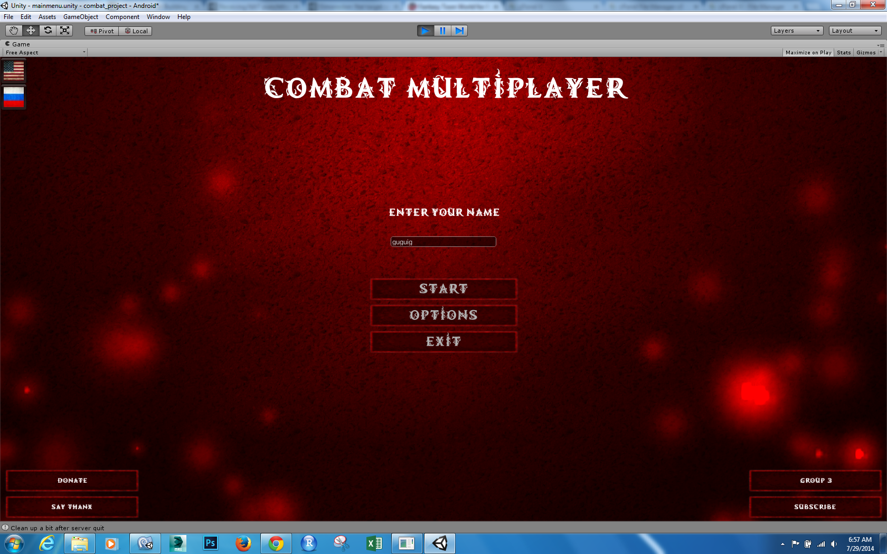

Once User connected to the server, below page pops up.



The below screen shot shows the gaming environment, Here user has to operate sensor tag to walk, rotate, aim and target the opponent player to shoot and kill the player.



## Offline Application: Activity Report

**Devices/Sensors:**

Devices which we have used for our emotion detection application are:

* Android mobile device
* Sensor Tag

The sensor tag here we used is a product of Texas Instruments.

**Motion Models:**

We used four hand gestures to detect. Since we already have sequence files of the trained data. Now the new gesture data will be collected using the sensor tag and then a sequence file will be generated for these data. Now these sequence file will be compared with the trained sequence files and the appropriate gesture is detected.

1. Left Hand gesture is represented as Left
2. Right Hand gesture is represented as Right
3. Stomp hand gesture is represented as Walk
4. Punch hand gesture is represented as Shoot

**Application Features:**

Multiple players can join the application server and play shooting each other. Each Player has to shoot thrice (three times) the other player to kill him/her. These application is basically designed for the Android users and the support will be provided starting from SDK version 18 till SDK version 19. Users have to install Unity 3D plugin to load 3D gaming environment. Here overall accuracy of sensor motion is recorded as 95%.

**Recognition/ Analysis Approaches:**

As mentioned earlier in our application we have used the K-NN logic and also HMM model for the detection of hand gestures. Using already prepared sequence files our application works efficiently with minimum time delay of less than one sec. Now in our application on the foreground we will first detect the hand gesture. This will be done by using two buttons namely “Start recognition” and “End recognition” which indicates the start and end of hand gesture respectively. The detect motion has two important methods

* Train()
* Test()

In the train function first we shall take the trained sequence files and train the application. Now once we have the trained results, which will be stored internally in the cache by the K-NN algorithm, we shall take the currently tapped sequence file data and map them to the trained results so as to detect the emotion.

**Evaluation: Motion/Activity Recognition**

**Number of Users:**

The data has been collected from five users and each user will be making five samples of actions for each gesture.

**Types of Motion/Activities:**

We have typically used four gestures in our application to detect different motions. The four gestures which we use for detection are:

1. Left Hand gesture is represented as Left move
2. Up Hand gesture is represented as Right move
3. Stomp hand gesture is represented as Walk
4. Punch hand gesture is represented as Shoot

**Size of Data/Number of Gestures:**

The size of data for each trained gesture is found to be around 25 KB based on the gesture. But each training file has a huge number of values which are found be good enough for detecting the activities.

**Data Preparation:**

The data has been collected using the sensor tags. And after recording of each gesture we will be using these files for machine learning to generate the sequence files. The following are the snapshots of the respective data collected for one kind of gestures.



Sequence files:



**Reports generated:**

**Steps involved in preparing Offline charts:**

1. Train sequence files through HMM
2. Push data to HBase
3. Pull Data from HBase and send it to High Charts
4. Generate Reports

* **Bar Chart**



* **Pie Chart**



* **Line Chart**



**Confusion Matrix:**

Accuracy has been calculated using trained data collected from sequence files for all sensor motions left, right, stomp, and punch. We have seen 100% accuracy for Left and Right motions whereas for walk it is 91% and for shoot is 89%.

**Observations:**

|  |  |  |  |  |
| --- | --- | --- | --- | --- |
| Observations | Left | Right | Walk | Shoot |
| Left | 10 | 0 | 0 | 0 |
| Right | 0 | 10 | 0 | 0 |
| Walk | 0 | 0 | 10 | 0 |
| Shoot | 0 | 0 | 2 | 8 |

**Accuracy:**

|  |  |  |  |
| --- | --- | --- | --- |
| Accuracy | Precision | Recall | F-Measure |
| Left | 1 | 1 | 1 |
| Right | 1 | 1 | 1 |
| Walk | 0.833 | 1 | 0.908 |
| Shoot | 1 | 0.8 | 0.888 |

**Limitations:**

Amount rotations made by each player may not be accurate if the sensor tag is not moved properly.

**Project Video:**

The following is the URL for the video presentation on the application usage and its brief insight:

## <http://youtu.be/tH3MXTsYfVQ>

## Related Work:

**Combat Trigger: Modern Dead 3D**

It is a war game where user can select different weapons and fight in different battle fields.

**Features included:**

Exciting campaign with plenty of battles, futuristic weapon, big bang grenades, armor and health customization, millions of enemies to kill, exotic planets and fallen human cities to fight in, battlefields on exotic planets, combat in fallen human cities

# Source Code

* **SensorTagData.java**

import android.bluetooth.BluetoothGattCharacteristic;

public class SensorTagData {

public static double extractHumAmbientTemperature(BluetoothGattCharacteristic c) {

int rawT = shortSignedAtOffset(c, 0);

return -46.85 + 175.72/65536 *(double)rawT;

}

public static double extractHumidity(BluetoothGattCharacteristic c) {

int a = shortUnsignedAtOffset(c, 2);

// bits [1..0] are status bits and need to be cleared

a = a - (a % 4);

return ((-6f) + 125f * (a / 65535f));

}

public static int[] extractCalibrationCoefficients(BluetoothGattCharacteristic c) {

int[] coefficients = new int[8];

coefficients[0] = shortUnsignedAtOffset(c, 0);

coefficients[1] = shortUnsignedAtOffset(c, 2);

coefficients[2] = shortUnsignedAtOffset(c, 4);

coefficients[3] = shortUnsignedAtOffset(c, 6);

coefficients[4] = shortSignedAtOffset(c, 8);

coefficients[5] = shortSignedAtOffset(c, 10);

coefficients[6] = shortSignedAtOffset(c, 12);

coefficients[7] = shortSignedAtOffset(c, 14);

return coefficients;

}

public static double extractBarTemperature(BluetoothGattCharacteristic characteristic, final int[] c) {

// c holds the calibration coefficients

int t_r; // Temperature raw value from sensor

double t_a; // Temperature actual value in unit centi degrees celsius

t_r = shortSignedAtOffset(characteristic, 0);

t_a = (100 * (c[0] * t_r / Math.pow(2,8) + c[1] * Math.pow(2,6))) / Math.pow(2,16);

return t_a / 100;

}

public static double extractBarometer(BluetoothGattCharacteristic characteristic, final int[] c) {

// c holds the calibration coefficients

int t_r; // Temperature raw value from sensor

int p_r; // Pressure raw value from sensor

double S; // Interim value in calculation

double O; // Interim value in calculation

double p_a; // Pressure actual value in unit Pascal.

t_r = shortSignedAtOffset(characteristic, 0);

p_r = shortUnsignedAtOffset(characteristic, 2);

S = c[2] + c[3] * t_r / Math.pow(2,17) + ((c[4] * t_r / Math.pow(2,15)) * t_r) / Math.pow(2,19);

O = c[5] * Math.pow(2,14) + c[6] * t_r / Math.pow(2,3) + ((c[7] * t_r / Math.pow(2,15)) * t_r) / Math.pow(2,4);

p_a = (S * p_r + O) / Math.pow(2,14);

//Convert pascal to in. Hg

double p_hg = p_a * 0.000296;

return p_hg;

}

/**

* Gyroscope, Magnetometer, Barometer, IR temperature

* all store 16 bit two's complement values in the awkward format

* LSB MSB, which cannot be directly parsed as getIntValue(FORMAT_SINT16, offset)

* because the bytes are stored in the "wrong" direction.

*

* This function extracts these 16 bit two's complement values.

* */

private static Integer shortSignedAtOffset(BluetoothGattCharacteristic c, int offset) {

Integer lowerByte = c.getIntValue(BluetoothGattCharacteristic.FORMAT_UINT8, offset);

Integer upperByte = c.getIntValue(BluetoothGattCharacteristic.FORMAT_SINT8, offset + 1); // Note: interpret MSB as signed.

return (upperByte << 8) + lowerByte;

}

private static Integer shortUnsignedAtOffset(BluetoothGattCharacteristic c, int offset) {

Integer lowerByte = c.getIntValue(BluetoothGattCharacteristic.FORMAT_UINT8, offset);

Integer upperByte = c.getIntValue(BluetoothGattCharacteristic.FORMAT_UINT8, offset + 1); // Note: interpret MSB as unsigned.

return (upperByte << 8) + lowerByte;

}

public static Float[] extractAccelerometerReading(final BluetoothGattCharacteristic c, int offset){

/*

* The accelerometer has the range [-2g, 2g] with unit (1/64)g.

*

* To convert from unit (1/64)g to unit g we divide by 64.

*

* (g = 9.81 m/s^2)

*

* The z value is multiplied with -1 to coincide

* with how we have arbitrarily defined the positive y direction.

* (illustrated by the apps accelerometer image)

* */

Integer x = c.getIntValue(BluetoothGattCharacteristic.FORMAT_SINT8, offset);

Integer y = c.getIntValue(BluetoothGattCharacteristic.FORMAT_SINT8, offset+1);

Integer z = c.getIntValue(BluetoothGattCharacteristic.FORMAT_SINT8, offset+2) * -1;

float scaledX = x / 64.0f;

float scaledY = y / 64.0f;

float scaledZ = z / 64.0f;

Float[] data = {scaledX,scaledY,scaledZ} ;

return data;

}

public static String extractGyroscopeReading(final BluetoothGattCharacteristic c, int offset){

float y = shortSignedAtOffset(c, offset) * (500f / 65536f) * -1;

float x = shortSignedAtOffset(c, offset+2) * (500f / 65536f);

float z = shortSignedAtOffset(c, offset+4) * (500f / 65536f);

return Float.toString(x)+Float.toString(y)+Float.toString(z);

}

static enum SimpleKeysStatus {

// Warning: The order in which these are defined matters.

OFF_OFF, OFF_ON, ON_OFF, ON_ON;

}

public static SimpleKeysStatus extractSimpleKeysValue(BluetoothGattCharacteristic c) {

/*

* The key state is encoded into 1 unsigned byte.

* bit 0: right key.

* bit 1: left key.

* bit 2: side key (test mode only).

*/

Integer encodedInteger = c.getIntValue(BluetoothGattCharacteristic.FORMAT_UINT8, 0);

SimpleKeysStatus newValue = SimpleKeysStatus.values()[encodedInteger % 4];

return newValue;

}

}

* **MainActivity.java**

import com.unity3d.player.UnityPlayer;

import com.unity3d.player.UnityPlayerActivity;

import android.app.Activity;

import android.content.BroadcastReceiver;

import android.content.Context;

import android.content.Intent;

import android.content.IntentFilter;

import android.os.Bundle;

import android.util.Log;

import android.view.Menu;

import android.view.MenuItem;

public class MainActivity extends UnityPlayerActivity {

public static String output;

public static String data="test";

public static int punchcount=0;

public static int walkcount=0;

public static int leftcount=0;

public static int rightcount=0;

private Activity _activity;

public static double Xvalue=0.0;

public static double Yvalue=0.0;

public static boolean leftkey=false;

public static boolean rightkey=false;

@Override

protected void onCreate(Bundle savedInstanceState) {

super.onCreate(savedInstanceState);

//setContentView(R.layout.activity_main);

_activity=UnityPlayer.currentActivity;

startService(new Intent(this,DataService.class));

}

private BroadcastReceiver receiver = new BroadcastReceiver() {

@Override

public void onReceive(Context context, Intent intent) {

Bundle bundle = intent.getExtras();

if (bundle!=null) {

String datas = bundle.getString("data");

Log.i("data in main class", datas);

data=datas;

if("punch".equalsIgnoreCase(data))

{

punchcount=punchcount+1;

}else if("walk".equalsIgnoreCase(data))

{

walkcount=walkcount+1;

}else if("left".equalsIgnoreCase(data))

{

leftcount=leftcount+1;

}else if("right".equalsIgnoreCase(data))

{

rightcount=rightcount+1;

}

//Toast.makeText(getApplicationContext(), "Ok", Toast.LENGTH_SHORT).show();

}else{

Log.i("data in main class", "bundle null");

//Toast.makeText(getApplicationContext(), "not", Toast.LENGTH_SHORT).show();

}

//handleResult(bundle);

}

};

@Override

protected void onResume() {

super.onResume();

registerReceiver(receiver, new IntentFilter("myproject"));

/*

* We need to enforce that Bluetooth is first enabled, and take the

* user to settings to enable it if they have not done so.

*/

/*

* Check for Bluetooth LE Support. In production, our manifest entry will keep this

* from installing on these devices, but this will allow test devices or other

* sideloads to report whether or not the feature exists.

*/

}

@Override

protected void onPause() {

super.onPause();

//Make sure dialog is hidden

//mProgress.dismiss();

//Cancel any scans in progress

//ds.Pause();

}

@Override

protected void onStop() {

super.onStop();

//Disconnect from any active tag connection

//ds.Stop();

stopService(new Intent(this, DataService.class));

}

public static String getAccelerometerData() {

return data;

}

public static void setAccelerometerData(String text)

{

data=text;

}

public static double getX()

{

return Xvalue;

}

public static void setX(Double val)

{

Xvalue=val;

}

public static double getY()

{

return Yvalue;

}

public static void setY(Double val)

{

Yvalue=val;

}

public static int getPunchcount() {

return punchcount;

}

public static int getWalkcount() {

return walkcount;

}

public static int getLeftcount() {

return leftcount;

}

public static int getRightcount() {

return rightcount;

}

public static boolean isLeftkey() {

return leftkey;

}

public static void setLeftkey(boolean leftkey) {

MainActivity.leftkey = leftkey;

}

public static boolean isRightkey() {

return rightkey;

}

public static void setRightkey(boolean rightkey) {

MainActivity.rightkey = rightkey;

}

public static void setPunchcount(int pu) {

punchcount = pu;

}

}

* **DataService.java**

import java.io.File;

import java.io.FileOutputStream;

import java.io.FileWriter;

import java.util.ArrayList;

import java.util.Arrays;

import java.util.HashMap;

import java.util.Iterator;

import java.util.List;

import java.util.Map;

import java.util.UUID;

import be.ac.ulg.montefiore.run.jahmm.Hmm;

import be.ac.ulg.montefiore.run.jahmm.ObservationVector;

import be.ac.ulg.montefiore.run.jahmm.OpdfMultiGaussianFactory;

import be.ac.ulg.montefiore.run.jahmm.learn.BaumWelchLearner;

import be.ac.ulg.montefiore.run.jahmm.learn.KMeansLearner;

import com.vishnu.sensorunity.SensorTagData;

import com.vishnu.sensorunity.SensorTagData.SimpleKeysStatus;

import android.app.Service;

import android.bluetooth.BluetoothAdapter;

import android.bluetooth.BluetoothDevice;

import android.bluetooth.BluetoothGatt;

import android.bluetooth.BluetoothGattCallback;

import android.bluetooth.BluetoothGattCharacteristic;

import android.bluetooth.BluetoothGattDescriptor;

import android.bluetooth.BluetoothManager;

import android.bluetooth.BluetoothProfile;

import android.content.Intent;

import android.content.pm.PackageManager;

import android.os.Environment;

import android.os.Handler;

import android.os.IBinder;

import android.os.Message;

import android.util.Log;

import android.util.SparseArray;

import android.widget.Toast;

public class DataService extends Service implements BluetoothAdapter.LeScanCallback{

//varible declaratioin start

private static final String TAG = "BluetoothGattActivity";

private static final String DEVICE_NAME = "SensorTag";

/* Acceleromter configuration servcie */

private static final UUID ACCELEROMETER_SERVICE = UUID.fromString("f000aa10-0451-4000-b000-000000000000");

private static final UUID ACCELEROMETER_DATA_CHAR = UUID.fromString("f000aa11-0451-4000-b000-000000000000");

private static final UUID ACCELEROMETER_CONFIG_CHAR = UUID.fromString("f000aa12-0451-4000-b000-000000000000");

private static final UUID ACCELEROMETER_PERIOD_CHAR = UUID.fromString("f000aa13-0451-4000-b000-000000000000");

/* Simple Keys */

private static final UUID SIMPLE_KEYS_SERVICE = UUID.fromString("0000ffe0-0000-1000-8000-00805f9b34fb");

private static final UUID SIMPLE_KEYS_DATA = UUID.fromString("0000ffe1-0000-1000-8000-00805f9b34fb");

/* Client Configuration Descriptor */

private static final UUID CONFIG_DESCRIPTOR = UUID.fromString("00002902-0000-1000-8000-00805f9b34fb");

private BluetoothAdapter mBluetoothAdapter;

private SparseArray<BluetoothDevice> mDevices;

private SimpleKeysStatus state;// = SimpleKeysStatus.OFF_OFF;

private BluetoothGatt mConnectedGatt;

double x1,y1,z1,d=0.0f,norm;

Boolean trigger=false;

ArrayList<String> dataPoints = new ArrayList<String>();

Boolean gesture = false;

StringBuffer buffer = new StringBuffer();

// variable declaration end

String[] Items;

private static int testCounter =0;

private Boolean testStart=false;

Hmm<ObservationVector> initHmmPunch=null;

Hmm<ObservationVector> learntHmmPunch=null;

Hmm<ObservationVector> learntHmmScrolldown=null;

Hmm<ObservationVector> learntHmmSend=null;

static Hmm<ObservationVector> learn0=null;

static Hmm<ObservationVector> learn1=null;

static Hmm<ObservationVector> learn2=null;

static Hmm<ObservationVector> learn3=null;

static Hmm<ObservationVector> learn4=null;

static Hmm<ObservationVector> learn5=null;

static Hmm<ObservationVector> learn6=null;

static Hmm<ObservationVector> learn7=null;

static Hmm<ObservationVector> learn8=null;

static Hmm<ObservationVector> learn9=null;

static Map<Hmm<ObservationVector>,String> HMMMap = new HashMap<Hmm<ObservationVector>,String>();

public String TemperatureData,HumidityData,AccelerometerData,PressureData="";

// private TextView mTemperature, mHumidity, mPressure,mAccelerometer;

public boolean CheckBluetooth()

{

if (mBluetoothAdapter == null || !mBluetoothAdapter.isEnabled()) {

//Bluetooth is disabled

//Intent enableBtIntent = new Intent(BluetoothAdapter.ACTION_REQUEST_ENABLE);

//startActivity(enableBtIntent);

//finish();

android.widget.Toast.makeText(this, "Bluetooth is Turned off.Please Turn On and Start The Game.", android.widget.Toast.LENGTH_LONG).show();

return false;

}else

{

return true;

}

}

public boolean CheckBLE()

{

if (!getPackageManager().hasSystemFeature(PackageManager.FEATURE_BLUETOOTH_LE)) {

android.widget.Toast.makeText(this, "No LE Support.", android.widget.Toast.LENGTH_LONG).show();

//finish();

return false;

}else

{

return true;

}

}

@Override

public int onStartCommand(Intent intent, int flags, int startId)

{

BluetoothManager manager = (BluetoothManager) getSystemService(BLUETOOTH_SERVICE);

mBluetoothAdapter = manager.getAdapter();

mDevices = new SparseArray<BluetoothDevice>();

if(CheckBLE() == true && CheckBluetooth()==true)

{

Log.i(TAG, "Bluetooth check and BLE check Passes");

//mBluetoothAdapter.startLeScan(this);

startScan();

}

if(testStart==false)

{

String[] punchdata=new String[]{"0.0,-0.28125,-0.21875:-0.109375,-0.59375,-0.25:-0.265625,-0.59375,0.0:-0.25,0.078125,-0.046875:-0.3125,-0.125,-0.1875:-0.140625,-0.15625,-0.125:0.0,-0.140625,0.21875:0.046875,-0.21875,0.296875:-0.109375,-0.390625,-0.015625:0.0,-0.3125,-0.015625",

"-0.125,-0.453125,0.359375:0.015625,-0.265625,0.140625:0.03125,-0.078125,-0.609375:-0.265625,0.421875,-0.078125:-0.09375,0.28125,-0.046875:-0.25,-0.109375,-0.203125:-0.1875,-0.1875,-0.203125:-0.0625,-0.078125,0.09375:-0.078125,-0.15625,0.265625:-0.125,-0.390625,0.0625:-0.046875,-0.40625,-0.046875:-0.046875,-0.328125,0.015625",

"-0.125,-0.453125,-0.203125:0.0,-0.125,-0.5625:-0.71875,-0.5,-0.03125:-0.28125,0.21875,-0.125:-0.078125,-0.15625,-0.21875:-0.078125,-0.15625,-0.015625:-0.078125,-0.15625,0.296875:-0.109375,-0.296875,0.15625:-0.0625,-0.421875,0.015625:0.015625,-0.296875,-0.015625",

"-0.046875,-0.28125,-0.109375:-0.0625,0.015625,-0.34375:-0.53125,-0.6875,-0.09375:-0.21875,0.0625,-0.109375:-0.34375,-0.140625,-0.1875:-0.109375,-0.140625,-0.171875:0.0,-0.15625,0.078125:-0.015625,-0.125,0.1875:-0.015625,-0.34375,0.0625:-0.0625,-0.53125,-0.046875:-0.03125,-0.28125,0.0",

"-0.0625,-0.46875,0.34375:-0.046875,-0.21875,0.09375:-0.03125,-0.203125,-0.421875:-0.0625,0.015625,-0.21875:-0.296875,-0.421875,-0.09375:-0.296875,-0.078125,-0.171875:-0.171875,-0.125,-0.203125:-0.046875,-0.125,-0.015625:-0.046875,-0.125,0.265625:-0.015625,-0.328125,0.125:0.0625,-0.390625,0.03125:0.015625,-0.265625,0.0",

"-0.046875,-0.28125,-0.1875:0.0,-0.046875,-0.484375:-0.53125,-0.1875,-0.046875:-0.234375,-0.234375,-0.078125:-0.234375,-0.234375,-0.21875:-0.171875,-0.15625,-0.046875:-0.015625,-0.109375,0.203125:-0.03125,-0.25,0.171875:-0.015625,-0.421875,0.03125",

"-0.015625,-0.359375,-0.140625:-0.078125,-0.203125,-0.53125:-0.28125,-0.0625,-0.0625:-0.171875,-0.015625,-0.046875:-0.234375,-0.109375,-0.234375:-0.1875,-0.1875,-0.140625:-0.0625,-0.0625,0.140625:0.015625,-0.203125,0.21875:-0.078125,-0.46875,0.015625",

"0.015625,-0.34375,-0.125:-0.078125,-0.0625,-0.5:-0.484375,-0.1875,-0.078125:-0.265625,0.03125,-0.09375:-0.265625,-0.203125,-0.25:-0.125,-0.125,-0.09375:-0.0625,-0.0625,0.1875:0.078125,-0.21875,0.15625:-0.03125,-0.515625,0.03125:0.0,-0.3125,-0.015625",

"-0.03125,0.1875,-0.4375:-0.03125,0.1875,-0.046875:0.015625,-0.171875,0.0:-0.171875,-0.046875,-0.203125:-0.21875,-0.1875,-0.171875:-0.09375,-0.046875,0.125:-0.015625,-0.15625,0.234375:-0.0625,-0.53125,0.0625:-0.015625,-0.390625,0.0:-0.015625,-0.28125,0.0",

"-0.125,-0.21875,-0.375:-0.421875,0.078125,-0.078125:-0.203125,-0.140625,-0.09375:-0.234375,-0.0625,-0.234375:-0.140625,-0.125,0.046875:-0.015625,-0.109375,0.28125:-0.046875,-0.328125,0.0625:0.03125,-0.453125,0.03125:0.03125,-0.28125,0.0",

"-0.046875,-0.359375,-0.25:-0.046875,0.03125,-0.359375:-0.609375,-0.28125,-0.03125:-0.125,0.15625,-0.171875:-0.234375,-0.1875,-0.1875:-0.046875,-0.140625,0.046875:-0.0625,-0.4375,0.265625:-0.0625,-0.4375,0.03125",

"-0.1875,0.203125,-0.296875:-0.1875,0.203125,-0.171875:-0.1875,-0.40625,-0.015625:-0.296875,0.0625,0.0:-0.359375,-0.109375,-0.1875:-0.1875,-0.15625,-0.140625:0.015625,-0.125,0.171875:0.0,-0.21875,0.25:0.0,-0.40625,0.0625",

"-0.09375,-0.421875,-0.1875:0.078125,0.125,-0.3125:-0.09375,-0.4375,-0.046875:-0.453125,0.015625,-0.0625:-0.34375,-0.140625,-0.21875:-0.203125,-0.125,-0.078125:-0.015625,-0.140625,0.21875:0.0625,-0.296875,0.203125:0.046875,-0.421875,0.015625:0.046875,-0.25,-0.015625",

"-0.03125,-0.3125,0.015625:0.09375,-0.078125,-0.484375:-0.296875,-0.015625,-0.078125:0.015625,-0.25,-0.40625:-0.15625,0.1875,-0.203125:-0.078125,-0.484375,-0.03125:-0.390625,-0.109375,-0.140625:-0.296875,-0.1875,-0.21875:-0.03125,-0.09375,0.03125:-0.03125,-0.140625,0.296875:-0.046875,-0.515625,0.109375:0.03125,-0.421875,0.015625:0.015625,-0.21875,0.015625",

"0.0,-0.390625,0.359375:-0.09375,-0.40625,0.203125:-0.0625,-0.25,-0.5:0.046875,0.359375,-0.0625:-0.015625,-0.203125,0.015625:-0.203125,-0.015625,-0.15625:-0.28125,-0.1875,-0.203125:-0.09375,-0.125,0.046875:-0.09375,-0.171875,0.296875:0.03125,-0.46875,0.09375:0.09375,-0.375,0.0:0.0,-0.25,0.0",

"0.0,-0.390625,0.015625:-0.078125,-0.109375,-0.515625:-0.203125,0.015625,-0.046875:-0.015625,0.109375,0.015625:-0.28125,-0.046875,-0.015625:-0.34375,-0.171875,-0.1875:-0.203125,-0.171875,-0.15625:-0.015625,-0.125,0.1875",

"0.015625,-0.453125,0.0625:0.0,-0.28125,0.0:0.078125,-0.3125,0.0:0.1875,-0.0625,-0.484375:-0.390625,0.0,-0.09375:-0.171875,-0.078125,-0.046875:-0.234375,-0.078125,-0.21875:-0.21875,-0.09375,-0.0625:-0.03125,-0.109375,0.234375",

"0.03125,-0.109375,-0.421875:-0.34375,0.0,-0.0625:-0.203125,-0.15625,-0.015625:-0.359375,-0.09375,-0.203125:-0.203125,-0.0625,-0.15625:0.015625,-0.109375,0.203125:0.15625,-0.1875,0.15625:0.046875,-0.453125,0.0625:0.03125,-0.3125,-0.015625",

"0.03125,-0.21875,-0.03125:-0.1875,-0.09375,-0.328125:-0.234375,-0.015625,-0.0625:-0.140625,-0.125,0.015625:-0.265625,-0.0625,-0.25:-0.234375,-0.140625,-0.109375:-0.03125,-0.09375,0.234375:0.015625,-0.265625,0.234375:-0.015625,-0.421875,0.03125:0.0,-0.25,-0.015625"

}; //String[] stompdata=new String[]{"-2.0,1.984375,0.625:-2.0,-2.0,0.625:-0.609375,-1.671875,0.625:-0.390625,0.96875,0.625:0.265625,-0.484375,0.625:0.4375,-1.03125,0.625:0.375,-1.234375,0.625:0.34375,-1.125,0.625:0.21875,-1.078125,0.625:-0.0625,-0.171875,0.625:-1.578125,1.984375,0.625:-2.0,-2.0,0.625:-1.6875,-1.609375,0.625:-0.359375,-0.1875,0.625:0.09375,0.328125,0.625:0.28125,-0.53125,0.625:0.46875,-1.046875,0.625:0.484375,-0.890625,0.375","-0.6875,-1.171875,0.375:-0.203125,0.265625,0.375:0.15625,-0.28125,0.375:0.296875,-0.90625,0.375:0.375,-1.265625,0.375:0.359375,-1.078125,0.375:0.25,-0.984375,0.375:-0.015625,-0.015625,0.375:-1.4375,1.984375,0.375:-2.0,-2.0,0.375:-1.921875,-1.109375,0.375:-0.4375,-0.359375,0.375:-0.03125,0.0625,0.375:0.453125,-1.015625,0.234375","0.03125,0.421875,-0.875:0.28125,-0.765625,-0.875:0.40625,-1.1875,-0.875:0.359375,-1.09375,-0.875:0.28125,-0.96875,-0.875:0.125,-0.53125,-0.875:-0.765625,1.984375,-0.875:-2.0,-1.03125,-0.875:-2.0,-2.0,-0.875:-1.078125,-1.734375,-0.875:-0.6875,0.84375,-0.875:0.09375,-0.3125,-0.875:0.25,-0.96875,-0.875:0.3125,-1.234375,-0.875:0.25,-0.953125,-0.875:0.109375,-0.640625,-0.875:-0.296875,0.796875,-0.875:-2.0,-2.0,-1.15625","0.015625,-0.265625,-1.15625:-0.84375,1.984375,-1.15625:-2.0,-2.0,-1.15625:-1.390625,-2.0,-1.15625:-0.9375,-0.328125,-1.15625:-0.203125,0.40625,-1.15625:0.34375,-0.921875,-1.15625:0.484375,-1.1875,-1.15625:0.375,-0.9375,-1.15625","-0.5,-0.90625,-1.984375:-0.515625,0.90625,-1.984375:0.265625,-0.796875,-1.984375:0.359375,-1.265625,-1.984375:0.265625,-0.96875,-1.984375:0.21875,-0.84375,-1.984375:-0.0625,-0.21875,-1.984375:-1.515625,1.984375,-1.984375:-2.0,-2.0,-1.984375:-1.140625,-1.953125,-1.984375:-1.015625,0.421875,-1.984375:-0.046875,0.28125,-1.984375:0.359375,-0.78125,-1.984375:0.46875,-1.140625,-1.984375:0.453125,-0.84375,-1.984375","-0.109375,0.65625,0.59375:-2.0,1.984375,0.59375:-2.0,-2.0,0.59375:-0.546875,-1.78125,0.59375:-1.25,0.625,0.59375:0.21875,-0.5625,0.59375:0.453125,-0.953125,0.59375","-0.265625,0.703125,-1.984375:-2.0,0.296875,-1.984375:-2.0,-2.0,-1.984375:-1.140625,-1.546875,-1.984375:-0.734375,-0.265625,-1.984375:-0.265625,0.53125,-1.984375:0.171875,-0.65625,-1.984375:0.15625,-0.703125,0.578125","-0.109375,0.078125,0.5:-1.234375,1.859375,0.5:-2.0,-2.0,0.5:-1.28125,-1.59375,0.5:-0.390625,-1.15625,0.5:-0.3125,-0.40625,0.5:-0.34375,0.296875,0.5:0.03125,-0.6875,0.5:0.28125,-1.140625,0.5:0.203125,-0.78125,0.5:-0.0625,-0.28125,0.5:-0.96875,1.671875,0.5:-2.0,-2.0,0.5:-0.9375,-1.953125,0.5:-0.015625,-0.609375,0.5:0.03125,-0.71875,0.5:0.21875,-0.734375,0.5:0.28125,-0.828125,0.5:0.234375,-0.96875,0.5"};

String[] walkdata=new String[]{"0.28125,-0.578125,-0.109375:0.15625,-0.375,0.125:-0.375,-0.28125,-0.328125:-1.125,-0.5625,-0.890625:1.3125,-1.65625,-0.28125:0.109375,-0.265625,0.1875:-0.640625,-0.375,-0.125:-0.96875,-0.40625,-0.75:1.765625,-1.296875,-0.0625:0.015625,-0.09375,0.015625",

"0.265625,-0.453125,-0.078125:0.203125,-0.390625,0.140625:-0.390625,-0.265625,-0.28125:-1.40625,-0.515625,-0.828125:1.78125,-1.84375,-0.40625:0.390625,-0.21875,0.140625:-0.40625,-0.359375,-0.015625:-1.171875,-0.390625,-0.734375:1.671875,-1.421875,-0.109375:0.140625,-0.078125,-0.125:0.09375,-0.234375,0.015625",

"-0.5625,-0.328125,-0.625:-1.046875,-0.96875,-0.546875:0.28125,-0.96875,-0.390625:0.109375,-0.4375,0.421875:-0.8125,-0.21875,-0.8125:-0.921875,-1.390625,0.140625:-0.25,-0.640625,0.03125:-0.0625,-0.015625,-0.03125:0.015625,-0.171875,0.0:0.109375,-0.328125,0.015625",

"-0.640625,-0.359375,-0.578125:-1.046875,-1.09375,-0.546875:0.203125,-1.3125,-0.359375:0.078125,-0.375,0.4375:-0.796875,-0.296875,-0.734375:-1.46875,-1.703125,0.234375:-0.4375,-0.875,-0.09375:-0.046875,-0.09375,-0.03125",

"0.453125,-0.609375,-0.0625:-0.21875,-0.390625,0.1875:-1.09375,-0.40625,-0.859375:1.984375,-2.0,-0.453125:0.390625,-0.296875,0.65625:-0.921875,-0.390625,-0.046875:-1.5625,-1.421875,-0.1875:-0.40625,-1.296875,-0.25:-0.140625,-0.078125,0.046875",

"0.109375,-0.296875,0.0:0.0,-0.390625,0.25:-0.75,-0.234375,-1.21875:1.984375,-2.0,-0.34375:0.4375,-0.265625,-0.15625:-0.234375,-0.53125,0.296875:-0.71875,-0.34375,-1.375:1.984375,-2.0,0.046875:0.09375,-0.28125,0.0625:-0.125,-0.09375,-0.046875:0.03125,-0.234375,0.015625",

"0.046875,-0.34375,0.515625:-1.21875,-0.28125,-1.25:1.984375,-2.0,-0.53125:0.46875,-0.234375,0.109375:-0.578125,-0.390625,0.1875:-1.40625,-0.4375,-0.84375:0.90625,-1.296875,-0.21875:0.046875,-0.046875,0.09375:-0.171875,-0.09375,-0.03125:0.234375,-0.390625,0.0:0.09375,-0.3125,0.0",

"0.4375,-0.5625,-0.015625:0.03125,-0.328125,0.328125:-0.546875,-0.28125,-1.1875:-0.578125,-0.515625,0.28125:-0.578125,-0.515625,-0.34375:-0.28125,-0.46875,0.46875:-0.609375,-0.34375,-1.296875:-0.75,-2.0,0.71875:-0.46875,-0.703125,-0.203125:-0.0625,-0.0625,0.03125",

"0.1875,-0.328125,-0.015625:0.34375,-0.546875,-0.015625:-0.125,-0.25,0.265625:-0.75,-0.328125,-1.375:1.03125,-2.0,-0.015625:-0.078125,-0.34375,-0.296875:-0.34375,-0.625,0.28125:-0.421875,-0.328125,-1.21875:-0.3125,-0.578125,0.734375:-0.3125,-0.578125,-0.09375:-0.046875,-0.046875,-0.015625",

"0.15625,-0.3125,0.015625:0.40625,-0.5625,-0.125:0.140625,-0.359375,0.25:-0.40625,-0.328125,-0.0625:-1.21875,-0.75,-1.203125:1.984375,-1.890625,-0.53125:0.28125,-0.296875,0.25:-0.71875,-0.4375,0.25:-1.328125,-0.546875,-1.203125:1.984375,-1.65625,0.078125:-0.046875,-0.03125,0.0625:-0.078125,-0.03125,-0.0625:0.109375,-0.28125,-0.015625",

"-0.375,-0.359375,0.359375:-1.015625,-0.53125,-1.640625:1.984375,-2.0,-0.4375:0.1875,-0.296875,0.5625:-0.6875,-0.4375,0.234375:-1.828125,-1.40625,0.28125:-0.46875,-1.234375,-0.125:-0.046875,0.0,-0.09375:0.0,-0.171875,-0.03125:0.046875,-0.328125,-0.015625",

"0.375,-0.5625,-0.078125:0.03125,-0.375,0.28125:-0.421875,-0.234375,-0.15625:-1.5625,-1.21875,-0.265625:0.015625,-1.5,-0.328125:-0.0625,-0.421875,0.4375:-0.578125,-0.453125,0.375:-1.1875,-0.828125,-0.84375:1.9375,-1.59375,-0.21875:0.1875,-0.0625,0.0625:-0.015625,-0.1875,-0.015625:0.171875,-0.328125,-0.015625",

"0.390625,-0.5,0.015625:0.015625,-0.34375,0.53125:-0.609375,-0.328125,-0.953125:-0.546875,-1.703125,-0.3125:-0.4375,-1.125,-0.3125:-0.0625,-0.421875,0.359375:-0.5,-0.28125,-0.0625:-1.9375,-1.3125,-0.4375:0.453125,-1.15625,-0.125:-0.015625,-0.1875,-0.078125",

"0.5625,-0.6875,-0.015625:-0.203125,-0.328125,0.484375:-0.6875,-0.390625,-1.234375:0.171875,-2.0,0.0625:-0.203125,-0.46875,-0.171875:-0.203125,-0.46875,0.21875:-0.3125,-0.296875,-1.0:-0.65625,-2.0,0.546875:-0.328125,-0.96875,-0.15625:0.046875,-0.078125,-0.09375:0.015625,-0.25,0.0",

"-0.046875,-0.359375,0.5625:-0.78125,-0.515625,-1.21875:1.984375,-2.0,-0.34375:0.265625,-0.234375,-0.140625:-0.265625,-0.734375,0.140625:-0.5625,-0.421875,-1.65625:1.984375,-2.0,-0.15625:0.1875,-0.140625,0.046875:-0.078125,-0.1875,0.0:0.078125,-0.296875,-0.015625",

"0.421875,-0.5,-0.0625:-0.046875,-0.28125,0.453125:-0.921875,-0.421875,-1.546875:1.8125,-2.0,-0.203125:0.046875,-0.28125,-0.296875:-0.34375,-0.59375,0.09375:-0.53125,-0.421875,-0.8125:1.984375,-2.0,0.140625:0.1875,-0.25,0.078125:-0.15625,-0.140625,-0.078125:0.078125,-0.25,0.03125",

"0.46875,-0.640625,-0.078125:-0.125,-0.5,0.6875:-0.90625,-0.4375,-1.4375:1.84375,-2.0,-0.109375:0.0625,-0.234375,0.03125:-0.859375,-0.640625,0.28125:-1.140625,-0.609375,-0.828125:1.640625,-1.4375,-0.265625:0.140625,-0.03125,0.03125:0.0,-0.234375,-0.015625:0.125,-0.3125,-0.015625",

"0.59375,-0.65625,-0.140625:-0.078125,-0.453125,0.359375:-0.5,-0.359375,-0.203125:-1.453125,-1.296875,-0.578125:0.1875,-1.515625,-0.390625:0.0,-0.4375,0.59375:-0.578125,-0.40625,-1.453125:0.21875,-2.0,0.9375:-0.5625,-0.40625,0.0625:-0.0625,-0.09375,-0.09375:0.109375,-0.28125,-0.015625",

"0.421875,-0.53125,-0.046875:0.03125,-0.5625,0.703125:-1.453125,-0.578125,-1.046875:1.640625,-2.0,-0.15625:-0.109375,-0.515625,0.0:-0.46875,-0.8125,0.328125:-0.828125,-0.640625,-1.328125:1.984375,-1.359375,-0.265625:0.1875,-0.0625,0.0:0.015625,-0.203125,0.015625:0.09375,-0.296875,-0.03125",

"0.453125,-0.46875,0.0:-0.03125,-0.4375,0.609375:-0.859375,-0.515625,-1.59375:1.984375,-2.0,0.140625:0.015625,-0.15625,-0.03125:-0.5625,-0.5625,0.296875:-1.328125,-0.671875,-1.15625:1.734375,-0.96875,-0.109375:0.109375,-0.109375,-0.015625:-0.0625,-0.171875,-0.015625:0.109375,-0.296875,0.0",

"0.40625,-0.484375,0.0:-0.21875,-0.390625,0.40625:-0.9375,-0.328125,-1.453125:1.984375,-1.671875,-0.28125:-0.03125,-0.3125,0.359375:-0.59375,-0.765625,0.359375:-1.28125,-0.796875,-1.03125:0.1875,-0.84375,-0.21875:0.171875,-0.09375,0.03125:-0.015625,-0.234375,-0.03125:0.140625,-0.265625,-0.015625",

"0.53125,-0.53125,-0.140625:-0.03125,-0.453125,0.453125:-0.53125,-0.40625,-1.4375:0.0625,-2.0,0.265625:-0.265625,-0.6875,-0.109375:-0.296875,-0.515625,0.359375:-0.921875,-0.546875,-1.1875:1.984375,-1.234375,-0.140625:0.15625,-0.109375,0.03125:-0.015625,-0.234375,-0.015625:0.09375,-0.265625,-0.03125",

"0.359375,-0.4375,-0.28125:0.328125,-0.625,0.53125:-0.953125,-0.546875,-0.84375:-0.375,-2.0,-0.25:-0.4375,-1.140625,-0.0625:-0.375,-0.546875,0.484375:-0.828125,-0.46875,-0.578125:1.984375,-2.0,-0.0625:0.03125,-0.171875,0.015625",

"0.546875,-0.546875,-0.125:0.09375,-0.46875,0.40625:-0.671875,-0.5,-1.0:0.234375,-2.0,0.015625:-0.125,-0.59375,-0.265625:-0.15625,-0.734375,0.1875:-0.609375,-0.546875,-1.328125:1.984375,-2.0,0.015625:0.0625,-0.203125,0.046875:-0.046875,-0.296875,0.0:0.109375,-0.296875,-0.03125",

"0.40625,-0.515625,-0.015625:-0.0625,-0.375,0.515625:-0.859375,-0.296875,-0.9375:1.984375,-2.0,-0.015625:-0.09375,-0.21875,-0.1875:-0.609375,-0.546875,0.234375:-0.0625,-0.96875,-0.78125:-0.0625,-0.96875,-0.1875:0.09375,0.0,-0.09375:0.109375,-0.25,0.015625",

"0.5,-0.59375,-0.125:0.140625,-0.3125,0.328125:-0.6875,-0.515625,-0.875:-0.015625,-1.671875,-0.09375:0.03125,-0.890625,-0.25:0.0,-0.546875,0.703125:-0.703125,-0.546875,-1.1875:0.3125,-2.0,1.375:-0.625,-0.453125,0.03125:-0.03125,-0.125,-0.078125:0.046875,-0.234375,0.0",

"0.515625,-0.546875,-0.046875:-0.015625,-0.3125,0.453125:-0.75,-0.3125,-0.890625:-0.140625,-0.671875,0.0:-0.140625,-0.671875,-0.25:-0.109375,-0.671875,0.125:-0.234375,-0.390625,-1.3125:1.984375,-2.0,0.734375:-0.328125,-0.203125,-0.046875:0.015625,-0.1875,-0.078125:0.109375,-0.265625,-0.046875",

"0.203125,-0.59375,-0.28125:0.4375,-0.59375,0.03125:-0.265625,-0.40625,0.40625:-0.71875,-0.53125,-1.171875:1.984375,-2.0,-0.171875:-0.046875,-0.203125,0.03125:-0.3125,-0.484375,0.359375:-0.625,-0.390625,-0.90625:1.984375,-2.0,-0.3125:0.046875,-0.265625,0.09375:-0.078125,-0.21875,-0.015625:0.03125,-0.265625,-0.015625",

"-0.3125,-0.453125,-0.25:-1.28125,-1.0625,-0.390625:1.46875,-1.6875,-0.328125:0.171875,-0.3125,0.734375:-0.78125,-2.0,-0.453125:-0.859375,-2.0,0.328125:-0.5,-0.84375,-0.0625:0.125,-0.109375,0.046875:0.046875,-0.234375,-0.03125:0.140625,-0.265625,0.0",

"0.578125,-0.515625,0.03125:-0.140625,-0.421875,0.5:-0.453125,-0.3125,-0.890625:-0.203125,-0.46875,0.375:-0.203125,-0.46875,-0.0625:-0.1875,-0.34375,0.375:-0.625,-0.3125,-0.328125:1.984375,-2.0,0.296875:-0.21875,-0.21875,-0.046875:-0.015625,-0.15625,-0.03125:0.171875,-0.28125,-0.015625",

"0.421875,-0.484375,-0.140625:-0.390625,-0.40625,0.09375:-0.390625,-0.40625,-0.765625:-0.21875,-2.0,0.28125:0.21875,-0.8125,-0.109375:-0.0625,-0.40625,0.53125:-0.71875,-0.390625,-1.109375:1.984375,-2.0,0.671875:-0.109375,-0.28125,0.03125:-0.125,-0.171875,-0.078125:0.171875,-0.234375,0.03125:0.078125,-0.28125,0.0",

"-0.046875,-0.3125,0.46875:-0.59375,-0.34375,-1.734375:0.765625,-2.0,0.515625:-0.265625,-0.5,-0.3125:-0.1875,-0.546875,0.515625:-0.9375,-0.390625,-1.09375:1.984375,-1.390625,-0.3125:0.15625,-0.1875,0.0625:-0.046875,-0.203125,-0.015625:0.078125,-0.265625,-0.03125",

"-0.0625,-0.3125,0.765625:-1.265625,-0.40625,-1.09375:1.984375,-1.9375,-0.1875:0.078125,-0.21875,0.15625:-0.5,-0.578125,0.4375:-1.421875,-0.9375,-0.984375:0.53125,-1.046875,-0.25:0.171875,-0.03125,-0.015625:0.0,-0.1875,0.0:0.125,-0.265625,-0.03125",

"0.5,-0.53125,0.046875:-0.328125,-0.34375,0.46875:-1.578125,-1.078125,-0.421875:0.75,-1.6875,-0.28125:-0.109375,-0.359375,0.578125:0.65625,-2.0,-1.1875:0.65625,-2.0,1.15625:-0.6875,-0.328125,0.0:-0.03125,-0.140625,-0.09375:0.15625,-0.25,0.015625",

"0.5,-0.609375,-0.0625:-0.265625,-0.359375,0.34375:-1.4375,-0.71875,0.140625:-0.0625,-0.3125,-0.25:-0.0625,-0.3125,0.3125:-0.546875,-0.40625,-0.5:-1.421875,-2.0,0.234375:-0.765625,-1.1875,-0.109375:0.03125,-0.078125,-0.09375:0.109375,-0.234375,0.015625"

};

String[] newdata=new String[]{"0.28125,-0.359375,-0.265625:0.078125,-0.328125,-0.234375:-0.578125,-0.0625,-0.140625:-0.796875,-0.03125,-0.4375:-0.21875,-0.390625,-0.4375:0.28125,-0.234375,-0.203125:1.03125,-0.125,-0.21875:0.03125,-0.171875,-0.078125:-0.609375,-0.3125,0.0:-0.125,-0.296875,0.0",

"0.15625,-0.359375,-0.234375:-0.953125,-0.0625,-0.3125:-0.78125,-0.15625,-0.5625:0.0,-0.375,-0.375:0.859375,-0.0625,-0.265625:0.515625,-0.109375,-0.28125:-0.78125,-0.421875,-0.015625:-0.3125,-0.25,0.0:-0.0625,-0.328125,0.015625:0.015625,-0.265625,-0.015625",

"0.484375,-0.421875,-0.34375:-0.140625,-0.171875,-0.203125:-0.984375,-0.0625,-0.40625:-0.546875,-0.4375,-0.53125:0.203125,-0.375,-0.34375:1.4375,-0.046875,-0.359375:0.15625,-0.234375,-0.09375:-0.984375,-0.296875,-0.046875:-0.078125,-0.234375,0.015625",

"0.828125,-0.375,-0.3125:-0.359375,-0.21875,-0.140625:-0.859375,-0.0625,-0.375:-0.46875,-0.421875,-0.53125:0.3125,-0.375,-0.28125:1.390625,-0.140625,-0.359375:0.109375,-0.140625,-0.203125:-0.734375,-0.46875,0.015625:-0.09375,-0.25,-0.015625:0.03125,-0.28125,0.0",

"0.328125,-0.359375,-0.375:0.09375,-0.3125,-0.265625:-1.078125,-0.046875,-0.3125:-0.625,-0.328125,-0.546875:0.046875,-0.484375,-0.390625:1.21875,-0.125,-0.234375:0.265625,-0.171875,-0.3125:-0.6875,-0.546875,-0.03125:-0.34375,-0.265625,-0.015625:0.0625,-0.34375,0.0:0.03125,-0.21875,0.0",

"0.1875,-0.3125,-0.296875:0.625,-0.40625,-0.34375:-0.890625,-0.109375,-0.25:-0.765625,-0.0625,-0.59375:-0.1875,-0.546875,-0.484375:0.8125,-0.359375,-0.1875:0.90625,0.078125,-0.453125:-0.34375,-0.4375,-0.1875:-0.484375,-0.375,0.015625:0.0,-0.375,-0.015625:0.03125,-0.203125,0.0",

"1.125,-0.375,-0.359375:-0.65625,-0.125,-0.234375:-0.703125,-0.09375,-0.421875:0.5,-0.5625,-0.65625:0.5,-0.5625,-0.21875:0.84375,0.0625,-0.265625:-0.1875,-0.28125,-0.0625:-0.578125,-0.21875,-0.015625:-0.0625,-0.375,0.015625:0.03125,-0.234375,0.0",

"0.71875,-0.359375,-0.359375:-0.265625,-0.28125,-0.1875:-0.9375,0.046875,-0.375:-0.46875,-0.3125,-0.515625:0.203125,-0.46875,-0.21875:1.453125,-0.15625,-0.265625:-0.15625,-0.296875,-0.09375:-0.625,-0.265625,0.0:-0.171875,-0.3125,0.0:0.03125,-0.25,0.0",

"0.234375,-0.375,-0.28125:0.40625,-0.28125,-0.234375:-0.953125,-0.09375,-0.234375:-0.625,-0.140625,-0.5:-0.078125,-0.453125,-0.4375:0.875,-0.15625,-0.328125:0.59375,-0.0625,-0.28125:-0.875,-0.53125,-0.0625:-0.265625,-0.25,-0.015625:0.0,-0.28125,0.0",

"0.640625,-0.4375,-0.390625:-0.1875,-0.21875,-0.203125:-0.921875,-0.046875,-0.375:-0.5625,-0.328125,-0.625:0.140625,-0.453125,-0.21875:1.53125,-0.03125,-0.265625:0.0,-0.3125,-0.171875:-0.609375,-0.3125,-0.03125:-0.15625,-0.28125,-0.015625:0.0,-0.3125,-0.015625",

"0.59375,-0.453125,-0.421875:-0.125,-0.171875,-0.25:-0.875,-0.09375,-0.25:-0.546875,-0.328125,-0.546875:0.109375,-0.4375,-0.34375:0.234375,-0.203125,-0.25:-0.578125,-0.46875,-0.015625:-0.359375,-0.21875,0.0:-0.046875,-0.328125,0.0",

"0.53125,-0.359375,-0.390625:-0.078125,-0.25,-0.25:-0.859375,-0.0625,-0.28125:-0.625,-0.21875,-0.484375:0.046875,-0.5625,-0.390625:0.90625,-0.234375,-0.234375:0.578125,-0.03125,-0.28125:-0.453125,-0.4375,-0.0625:-0.421875,-0.265625,0.03125:-0.046875,-0.3125,0.015625:0.03125,-0.21875,0.0",

"0.8125,-0.46875,-0.34375:-0.46875,-0.140625,-0.25:-0.734375,-0.125,-0.328125:-0.46875,-0.390625,-0.59375:0.09375,-0.5,-0.28125:0.953125,-0.1875,-0.171875:0.484375,-0.109375,-0.375:-0.515625,-0.578125,-0.0625:-0.296875,-0.234375,0.015625:0.03125,-0.234375,0.0",

"0.796875,-0.46875,-0.40625:-0.40625,-0.109375,-0.265625:-0.8125,-0.09375,-0.390625:-0.40625,-0.40625,-0.46875:0.140625,-0.578125,-0.203125:0.359375,-0.234375,-0.15625:-0.5625,-0.453125,-0.015625:-0.25,-0.265625,-0.015625:-0.03125,-0.328125,0.0",

"0.859375,-0.34375,-0.1875:0.859375,-0.34375,-0.46875:-0.796875,-0.0625,-0.28125:-0.828125,-0.125,-0.46875:-0.328125,-0.46875,-0.484375:0.421875,-0.5,-0.171875:1.453125,-0.015625,-0.328125:-0.078125,-0.421875,-0.140625:-0.703125,-0.296875,0.03125:-0.125,-0.296875,0.015625:0.015625,-0.25,0.015625",

"0.796875,-0.4375,-0.40625:-0.78125,-0.140625,-0.171875:-0.8125,-0.03125,-0.453125:-0.484375,-0.5,-0.484375:0.21875,-0.5625,-0.296875:1.421875,-0.203125,-0.28125:0.09375,-0.328125,-0.109375:-0.78125,-0.359375,0.0:-0.09375,-0.3125,0.03125:0.0,-0.265625,0.015625",

"0.65625,-0.453125,-0.4375:-0.328125,-0.140625,-0.109375:-1.03125,-0.0625,-0.34375:-0.546875,-0.4375,-0.421875:0.09375,-0.515625,-0.359375:1.4375,-0.203125,-0.375:0.234375,-0.359375,-0.09375:-0.84375,-0.40625,0.03125:-0.109375,-0.25,0.046875:-0.015625,-0.296875,0.015625",

"0.796875,-0.453125,-0.375:-0.546875,-0.265625,-0.234375:-1.03125,-0.03125,-0.515625:-0.328125,-0.546875,-0.46875:0.203125,-0.53125,-0.28125:1.203125,-0.171875,-0.28125:0.3125,-0.3125,-0.125:-0.875,-0.40625,-0.015625:-0.0625,-0.296875,0.03125",

"0.75,-0.390625,-0.546875:-0.546875,-0.203125,-0.265625:-0.875,-0.09375,-0.4375:-0.25,-0.625,-0.375:0.34375,-0.46875,-0.21875:1.40625,-0.0625,-0.328125:0.03125,-0.359375,-0.125:-0.734375,-0.390625,0.0:-0.03125,-0.265625,0.03125",

"0.078125,-0.328125,-0.3125:0.8125,-0.53125,-0.296875:-0.953125,-0.046875,-0.25:-0.671875,-0.078125,-0.3125:-0.34375,-0.453125,-0.421875:0.515625,-0.4375,-0.25:1.390625,-0.046875,-0.234375:-0.328125,-0.453125,-0.03125:-0.515625,-0.296875,0.03125:-0.109375,-0.28125,0.03125:0.015625,-0.265625,0.015625",

"0.4375,-0.328125,-0.578125:0.203125,-0.390625,-0.1875:-1.078125,0.0625,-0.34375:-0.671875,-0.171875,-0.546875:0.109375,-0.703125,-0.328125:0.9375,-0.203125,-0.28125:-0.828125,-0.34375,-0.140625:-0.828125,-0.34375,-0.015625:-0.09375,-0.21875,0.03125:0.03125,-0.296875,0.015625",

"0.546875,-0.359375,-0.421875:0.265625,-0.328125,-0.25:-1.046875,-0.0625,-0.28125:-0.671875,-0.234375,-0.375:0.578125,-0.296875,-0.25:0.921875,-0.15625,-0.109375:-0.78125,-0.390625,0.0:-0.21875,-0.203125,0.03125:-0.015625,-0.328125,0.015625",

"0.625,-0.390625,-0.484375:-1.140625,-0.046875,-0.28125:-0.578125,-0.21875,-0.5625:0.140625,-0.609375,-0.265625:1.21875,-0.265625,-0.1875:0.203125,-0.25,-0.078125:-0.71875,-0.328125,0.0:-0.125,-0.265625,0.015625:0.015625,-0.265625,0.0",

"1.03125,-0.46875,-0.65625:-0.328125,-0.203125,-0.296875:-1.046875,0.0,-0.484375:-0.359375,-0.421875,-0.5:0.609375,-0.5,-0.203125:1.65625,0.28125,-0.296875:-0.734375,-0.671875,-0.078125:-0.1875,-0.21875,0.03125:-0.046875,-0.3125,-0.015625:0.078125,-0.265625,0.0",

"0.875,-0.421875,-0.546875:-0.703125,-0.140625,-0.296875:-0.921875,0.0625,-0.53125:-0.21875,-0.390625,-0.53125:0.4375,-0.625,-0.3125:0.84375,-0.203125,-0.1875:-0.9375,-0.265625,-0.03125:-0.15625,-0.234375,0.015625:-0.015625,-0.3125,0.0",

"1.359375,-0.453125,-0.6875:-0.609375,-0.1875,-0.328125:-1.015625,0.0,-0.46875:-0.1875,-0.5,-0.515625:0.609375,-0.515625,-0.234375:1.09375,-0.09375,-0.296875:-0.671875,-0.375,-0.03125:-0.25,-0.203125,0.03125:-0.015625,-0.28125,0.015625"

};

String[] rightdata=new String[]{"0.078125,-0.578125,-0.0625:0.078125,-0.578125,-0.234375:0.0625,-0.890625,-0.21875:-0.0625,0.0625,-0.15625:-0.15625,0.75,-0.34375:-0.15625,0.375,-0.75:0.171875,-0.953125,-0.15625:0.140625,-1.578125,-0.5:0.109375,-0.515625,-0.28125:-0.09375,0.296875,-0.25:-0.125,0.78125,-0.515625:-0.109375,0.15625,-0.125:-0.046875,-1.609375,-0.046875:0.078125,-0.25,-0.015625",

"0.15625,-0.953125,-0.203125:-0.03125,-0.359375,-0.203125:-0.078125,0.578125,-0.328125:-0.140625,0.640625,-0.8125:0.140625,-0.34375,-0.1875:0.015625,-0.53125,-0.515625:0.015625,-0.53125,-0.296875:-0.03125,0.3125,-0.296875:-0.046875,0.734375,-0.5:-0.0625,0.25,-0.21875:-0.171875,-1.96875,-0.046875:0.046875,-0.328125,-0.03125:-0.015625,-0.1875,-0.03125",

"0.109375,-1.15625,-0.3125:-0.03125,-0.203125,-0.3125:-0.046875,0.75,-0.40625:-0.171875,0.578125,-0.828125:0.328125,-0.71875,-0.15625:0.28125,-1.9375,-0.5625:0.03125,-0.421875,-0.40625:-0.03125,0.421875,-0.25:-0.140625,0.828125,-0.4375:0.125,-0.53125,0.03125:0.015625,-0.90625,0.0:0.0,-0.203125,-0.03125",

"0.0625,-0.84375,-0.15625:-0.03125,-0.703125,-0.234375:0.0,0.296875,-0.265625:-0.015625,0.703125,-0.59375:-0.125,0.1875,-0.59375:-0.03125,-1.78125,-0.390625:0.03125,-1.140625,-0.5625:0.015625,0.046875,-0.34375:-0.046875,0.921875,-0.40625:-0.203125,0.453125,-0.40625:-0.046875,-1.671875,0.0:0.015625,-0.203125,-0.046875",

"-0.078125,-1.0,-0.3125:0.0,-0.015625,-0.234375:-0.046875,0.8125,-0.421875:-0.140625,0.484375,-0.78125:0.28125,-0.953125,-0.25:-0.015625,-1.625,-0.671875:0.046875,-0.3125,-0.375:-0.046875,0.625,-0.28125:-0.09375,0.765625,-0.6875:-0.078125,-1.203125,-0.09375",

"-0.015625,-0.34375,-0.03125:-0.046875,-0.21875,-0.03125:0.03125,-0.609375,-0.15625:0.015625,-0.96875,-0.296875:-0.03125,0.109375,-0.296875:-0.046875,0.84375,-0.5625:-0.140625,0.484375,-0.859375:0.125,-1.703125,-0.40625:0.015625,-1.53125,-0.625:-0.078125,0.78125,-0.34375",

"-0.171875,0.515625,-0.609375:0.140625,-1.3125,-0.03125:0.0625,-0.578125,-0.015625:-0.03125,-0.234375,-0.03125:0.09375,-1.015625,-0.28125:-0.03125,-0.265625,-0.3125:-0.03125,0.75,-0.359375:-0.171875,0.546875,-0.859375:0.21875,-0.484375,-0.171875:0.0,-2.0,-0.53125:0.046875,-0.75,-0.453125:0.0,0.34375,-0.28125:-0.078125,0.8125,-0.453125:-0.140625,0.203125,-0.0625:-0.046875,-1.421875,0.046875:0.046875,-0.265625,0.0",

"0.03125,-0.515625,-0.15625:0.046875,-1.0625,-0.375:-0.046875,0.0,-0.234375:-0.125,0.953125,-0.546875:-0.171875,0.53125,-0.921875:0.3125,-1.171875,-0.28125:0.09375,-1.765625,-0.640625:0.0625,-0.1875,-0.359375:-0.09375,-0.1875,-0.296875:-0.078125,0.734375,-0.671875:0.109375,-0.734375,-0.03125",

"-0.0625,-0.21875,-0.03125:0.09375,-1.046875,-0.3125:-0.046875,-0.59375,-0.265625:-0.0625,0.421875,-0.3125:-0.015625,0.796875,-0.78125:0.03125,0.140625,-0.4375:0.0,-2.0,-0.4375:0.015625,-1.171875,-0.546875:0.015625,0.140625,-0.25:-0.046875,0.984375,-0.4375:-0.140625,0.296875,-0.28125:0.0,-1.65625,0.03125:0.03125,-0.4375,-0.015625:-0.03125,-0.234375,-0.015625",

"0.015625,-1.0625,-0.21875:0.0,-0.40625,-0.234375:-0.046875,0.390625,-0.34375:-0.0625,0.8125,-0.96875:0.015625,0.0,-0.28125:0.09375,-2.0,-0.625:0.046875,-0.8125,-0.484375:0.015625,0.328125,-0.265625:-0.0625,0.96875,-0.640625:-0.125,0.21875,-0.125:-0.0625,-1.53125,-0.015625:0.0,-0.3125,-0.03125",

"0.03125,-1.21875,-0.265625:0.0,-0.0625,-0.25:-0.046875,0.65625,-0.359375:-0.15625,0.546875,-0.71875:0.375,-2.0,-0.140625:0.125,-2.0,-0.5:0.09375,-0.5,-0.390625:0.03125,0.5625,-0.265625:-0.0625,0.859375,-0.71875:0.109375,-0.4375,-0.109375:-0.015625,-1.171875,0.0:-0.046875,-0.359375,-0.046875:-0.015625,-0.171875,-0.03125:0.0,-0.296875,-0.03125",

"-0.09375,0.359375,-0.3125:0.0,0.84375,-0.890625:0.078125,0.0625,-0.203125:-0.046875,-2.0,-0.546875:0.046875,-0.8125,-0.515625:0.0,0.28125,-0.296875:0.0,0.96875,-0.625:-0.078125,0.234375,-0.1875:-0.1875,-1.75,0.03125:0.0,-0.296875,-0.0625"

};

//Log.i("Sizes", String.valueOf(stompdata.length)+String.valueOf(circledata.length));

HMMTraining(punchdata,"punch");

//HMMTraining(stompdata,"stomp");

HMMTraining(rightdata,"right");

HMMTraining(walkdata,"walk");

HMMTraining(newdata,"left");

}

testStart=true;

return START_NOT_STICKY;

}

public static void HMMTraining(String[] datas,String Action) {

String line="";

//String Trainfilename="HmmPunch.seq::HmmStomp.seq::HmmCircle.seq";

//String TestFile="combo.seq";

String Actionname=Action;

//Trainfilename = Trainfilename.replace("-","/");

// TestFile = TestFile.replace("-", "/");

//String TrainfileArr[]=Trainfilename.split("::");

List<ObservationVector> Sequence1=new ArrayList<ObservationVector>();

List<ObservationVector> Sequence2=new ArrayList<ObservationVector>();

List<ObservationVector> Sequence3=new ArrayList<ObservationVector>();

List<ObservationVector> Sequence4=new ArrayList<ObservationVector>();

List<ObservationVector> Sequence5=new ArrayList<ObservationVector>();

List<ObservationVector> Sequence6=new ArrayList<ObservationVector>();

List<ObservationVector> Sequence7=new ArrayList<ObservationVector>();

String[] Getdata=datas;

for(int k=0;k < 7;k++){

String dataString[]=Getdata[k].split(":");

for(int j=0;j<dataString.length;j++)

{

String axis[]=dataString[j].split(",");

double[] vec=new double[]{Double.valueOf(axis[0]),Double.valueOf(axis[1]),Double.valueOf(axis[2])};

ObservationVector ov=new ObservationVector(vec);

switch(k)

{

case 0:

Sequence1.add(ov);

break;

case 1:

Sequence2.add(ov);

break;

case 2:

Sequence3.add(ov);

break;

case 3:

Sequence4.add(ov);

break;

case 4:

Sequence5.add(ov);

break;

case 5:

Sequence6.add(ov);

break;

case 6:

Sequence7.add(ov);

break;

default:

break;

}

}

}

Boolean exception =false;

exception =false;

int x=10;

while(!exception){

OpdfMultiGaussianFactory initFactory = new OpdfMultiGaussianFactory(3);

try {

/*learnReader = new FileReader(new File (myDir,TrainfileArr[i]));

List<List<ObservationVector>> learnSequences = ObservationSequencesReader

.readSequences(new ObservationVectorReader(), learnReader);

learnReader.close();*/

List<List<ObservationVector>> learnSequences=Arrays.asList(Sequence1,Sequence2,Sequence3,Sequence4,Sequence5,Sequence6,Sequence7);

//Log.i("Punch Data", learnSequences.toString());

KMeansLearner<ObservationVector> kMeansLearner = new KMeansLearner<ObservationVector>(

x, initFactory, learnSequences);

// Create an estimation of the HMM (initHmm) using one iteration of the

// k-Means algorithm

Hmm<ObservationVector> initHmm = kMeansLearner.iterate();

// Use BaumWelchLearner to create the HMM (learntHmm) from initHmm

BaumWelchLearner baumWelchLearner0 = new BaumWelchLearner();

learn0 = baumWelchLearner0.learn(

initHmm, learnSequences);

exception=true;

HMMMap.put(learn0,Actionname);

} catch(Exception e){

x--;

}

}

line="training success for:"+Actionname+"\n";

line = line + "Start Test....\n";

line = line + "HMMMap size: " +HMMMap.size();

line = line + "\n" + HMMMap.get(learn0);

///////////////////////// Start Testing ///////////////////////////

/*

if (gesture == 1) {

line=line+"This is a punch gesture\n";

} else if (gesture == 2) {

line=line+"This is a right-left gesture\n";

} else if (gesture == 3) {

line=line+"This is a left to right gesture\n";

}*/

Log.i("Training Gestures",line);

}

public void TestGesture(ArrayList sequence)

{

String line = "";

try {

/* Reader testReader = new FileReader(TestFile);

List<List<ObservationVector>> testSequences = ObservationSequencesReader

.readSequences(new ObservationVectorReader(), testReader);

testReader.close();*/

List<ArrayList> testSequences=Arrays.asList(sequence);

// System.out.println(testSequences.get(0));

short gesture;

double Probability=0;

Map<Double,String> motionmap = new HashMap<Double,String>();

for (int i = 0; i < testSequences.size(); i++) {

Iterator<Hmm<ObservationVector>> HMMIte2 = HMMMap.keySet().iterator();

while (HMMIte2.hasNext()) {

Hmm<ObservationVector> learnModel = HMMIte2.next();

String motion = HMMMap.get(learnModel);

Probability=learnModel.probability(testSequences.get(i));

motionmap.put(Probability,motion);

}

double comp = 0;

Iterator<Double> motionIte2 = motionmap.keySet().iterator();

while (motionIte2.hasNext()) {

Double prob = motionIte2.next();

if(prob>comp)

{

comp=prob;

}

}

String finaldecision= motionmap.get(comp);

Intent intent = new Intent("myproject");

intent.putExtra("data", finaldecision);

sendBroadcast(intent);

line = line + "\n" + "highest probability is: "+comp + ", gesture is: "+finaldecision;

Log.i("Test Gesture", line);

}

} catch (Exception e) {

// TODO Auto-generated catch block

line=e.toString();

e.printStackTrace();

}

}

@Override

public void onDestroy()

{

if (mConnectedGatt != null) {

mConnectedGatt.disconnect();

mConnectedGatt = null;

}

}

public void Stop()

{

if (mConnectedGatt != null) {

mConnectedGatt.disconnect();

mConnectedGatt = null;

}

}

//first method to be invoked when the class loads

@Override

public void onCreate() {

super.onCreate();

BluetoothManager manager = (BluetoothManager) getSystemService(BLUETOOTH_SERVICE);

mBluetoothAdapter = manager.getAdapter();

mDevices = new SparseArray<BluetoothDevice>();

}

/*

* scans all BLE device in range and connects to device with name "SensorTag"(non-Javadoc)

* This method also trains the data to be used for recognition in the test method

*/

public String[] ListScannedItems()

{

for (int i=0; i < mDevices.size(); i++) {

BluetoothDevice device = mDevices.valueAt(i);

Items[i]=device.getName();

}

return Items;

}

public void CreateConnection(int i)

{

for(int k=0;k<mDevices.size();k++)

{

BluetoothDevice device = mDevices.get(mDevices.keyAt(k));

Log.i(TAG, "Address "+device.getAddress());

if(device.getAddress().contains("BC:6A:29:AC:1C:CF"))

{

Log.i(TAG, "Connecting to "+device.getName());

/*

* Make a connection with the device using the special LE-specific

* connectGatt() method, passing in a callback for GATT events

*/

mConnectedGatt = device.connectGatt(this, false, mGattCallback);

}

}

}

private Runnable mStopRunnable = new Runnable() {

@Override

public void run() {

stopScan();

}

};

private Runnable mStartRunnable = new Runnable() {

@Override

public void run() {

startScan();

}

};

private void startScan() {

mBluetoothAdapter.startLeScan(this);

//setProgressBarIndeterminateVisibility(true);

mHandler.postDelayed(mStopRunnable, 2500);

}

private void stopScan() {

mBluetoothAdapter.stopLeScan(this);

//setProgressBarIndeterminateVisibility(false);

if(mDevices.size() >0)

{

CreateConnection(0);

}

}

@Override

public void onLeScan(BluetoothDevice device, int rssi, byte[] scanRecord) {

Log.i(TAG, "New LE Device: " + device.getName() + " @ " + rssi);

/*

* We are looking for SensorTag devices only, so validate the name

* that each device reports before adding it to our collection

*/

if (DEVICE_NAME.equals(device.getName())) {

mDevices.put(device.hashCode(), device);

//mConnectedGatt = device.connectGatt(this, false, mGattCallback);

// stopScan();

// mBluetoothAdapter.stopLeScan(this);

// t.train();

}

}

/*

* In this callback, we've created a bit of a state machine to enforce that only

* one characteristic be read or written at a time until all of our sensors

* are enabled and we are registered to get notifications.

*/

private BluetoothGattCallback mGattCallback = new BluetoothGattCallback() {

/* State Machine Tracking */

private int mState = 0;

private void reset() { mState = 0; }

private void advance() { mState++; }

//after connecting to device, this method keeps track of the connection

@Override

public void onConnectionStateChange(BluetoothGatt gatt, int status, int newState) {

Log.d(TAG, "Connection State Change: "+status+" -> "+connectionState(newState));

if (status == BluetoothGatt.GATT_SUCCESS && newState == BluetoothProfile.STATE_CONNECTED) {

/*

* Once successfully connected, we must next discover all the services on the

* device before we can read and write their characteristics.

*/

gatt.discoverServices();

//mHandler.sendMessage(Message.obtain(null, MSG_PROGRESS, "Discovering Services..."));

} else if (status == BluetoothGatt.GATT_SUCCESS && newState == BluetoothProfile.STATE_DISCONNECTED) {

/*

* If at any point we disconnect, send a message to clear the weather values

* out of the UI

*/

// mHandler.sendEmptyMessage(MSG_CLEAR);

} else if (status != BluetoothGatt.GATT_SUCCESS) {

/*

* If there is a failure at any stage, simply disconnect

*/

gatt.disconnect();

}

}

/*

* Keeps track of the services discovered and sets the sensor characteristics to be written to device.

* (non-Javadoc)

* @see android.bluetooth.BluetoothGattCallback#onServicesDiscovered(android.bluetooth.BluetoothGatt, int)

*/

@Override

public void onServicesDiscovered(BluetoothGatt gatt, int status) {

reset();

state = SimpleKeysStatus.OFF_OFF;

setNextSensorCharacteristic(gatt);

}

/*

* This method writes the characteristics of each sensor which is being connected.

*/

private void setNextSensorCharacteristic(BluetoothGatt gatt) {

BluetoothGattCharacteristic characteristic;

switch (mState) {

case 0:

// enable accelerometer

characteristic = gatt.getService(ACCELEROMETER_SERVICE).getCharacteristic(ACCELEROMETER_CONFIG_CHAR);

characteristic.setValue(new byte[] { 0x01 });

break;

case 1:

//change the period of acceleration to maximum frequency. This value is the maximum value for this device

characteristic = gatt.getService(ACCELEROMETER_SERVICE).getCharacteristic(ACCELEROMETER_PERIOD_CHAR);

characteristic.setValue(new byte[] { (byte) 10 });

break;

default:

return;

}

gatt.writeCharacteristic(characteristic);

}

/*

* This method gets invoked once to read and check if the service is available and readable

* (non-Javadoc)

* @see android.bluetooth.BluetoothGattCallback#onCharacteristicRead(android.bluetooth.BluetoothGatt, android.bluetooth.BluetoothGattCharacteristic, int)

*/

@Override

public void onCharacteristicRead(BluetoothGatt gatt, BluetoothGattCharacteristic characteristic, int status) {

}

/*

* Method to write the characteristics to the device, such as period.

* (non-Javadoc)

* @see android.bluetooth.BluetoothGattCallback#onCharacteristicWrite(android.bluetooth.BluetoothGatt, android.bluetooth.BluetoothGattCharacteristic, int)

*/

@Override

public void onCharacteristicWrite(BluetoothGatt gatt, BluetoothGattCharacteristic characteristic, int status) {

//After writing the enable flag, next we read the initial value

enableNextSensorNotification(gatt);

}

/*

* method to enable different sensors in in the device.

*/

private void enableNextSensorNotification(BluetoothGatt gatt) {

BluetoothGattCharacteristic characteristic;

switch (mState) {

case 1:

// subscribe to accelerometer data notifications

characteristic = gatt.getService(ACCELEROMETER_SERVICE).getCharacteristic(ACCELEROMETER_DATA_CHAR);

break;

case 0:

// subscribe to simple keys data notifications

characteristic = gatt.getService(SIMPLE_KEYS_SERVICE).getCharacteristic(SIMPLE_KEYS_DATA);

break;

default:

return;

}

// Enable local notifications

gatt.setCharacteristicNotification(characteristic, true);

// Enabled remote notifications

BluetoothGattDescriptor desc = characteristic.getDescriptor(CONFIG_DESCRIPTOR);

desc.setValue(BluetoothGattDescriptor.ENABLE_NOTIFICATION_VALUE);

gatt.writeDescriptor(desc);

}

/*

* This method gets invoked regularly either based on time period set or if there is any change in the data from the device.

* (non-Javadoc)

* @see android.bluetooth.BluetoothGattCallback#onCharacteristicChanged(android.bluetooth.BluetoothGatt, android.bluetooth.BluetoothGattCharacteristic)

*/

@Override

public void onCharacteristicChanged(BluetoothGatt gatt, BluetoothGattCharacteristic characteristic) {

/*

* After notifications are enabled, all updates from the device on characteristic

* value changes will be posted here. Similar to read, we hand these up to the

* UI thread to update the display.

*/

if (ACCELEROMETER_DATA_CHAR.equals(characteristic.getUuid())) {

updateAccelerometerCals(characteristic);

}

if (SIMPLE_KEYS_DATA.equals(characteristic.getUuid())) {

state = SensorTagData.extractSimpleKeysValue(characteristic);

}

}

@Override

public void onDescriptorWrite(BluetoothGatt gatt, BluetoothGattDescriptor descriptor, int status) {

//Once notifications are enabled, we move to the next sensor and start over with enable

advance();

setNextSensorCharacteristic(gatt);

}

@Override

public void onReadRemoteRssi(BluetoothGatt gatt, int rssi, int status) {

Log.d(TAG, "Remote RSSI: "+rssi);

}

private String connectionState(int status) {

switch (status) {

case BluetoothProfile.STATE_CONNECTED:

return "Connected";

case BluetoothProfile.STATE_DISCONNECTED:

return "Disconnected";

case BluetoothProfile.STATE_CONNECTING:

return "Connecting";

case BluetoothProfile.STATE_DISCONNECTING:

return "Disconnecting";

default:

return String.valueOf(status);

}

}

};

/*

* Method which converts the raw data into acceleration values and tests the gesture based on start and end from the button presssed,

* sends a broadcast if detects a gesture.

*/

ArrayList sequence = new ArrayList();

double[] vec;

private void updateAccelerometerCals(BluetoothGattCharacteristic characteristic) {

Float[] values = SensorTagData.extractAccelerometerReading(characteristic,0);

double x,y,z;

x=values[0];

y=values[1];

z=values[2];

if(state==SimpleKeysStatus.ON_OFF)

{

MainActivity.leftkey=true;

Log.i(TAG, String.valueOf(MainActivity.leftkey));

}else if(state==SimpleKeysStatus.OFF_ON)

{

Log.i(TAG, "Right key pressed");

MainActivity.rightkey=true;

}else

{

MainActivity.leftkey=false;

MainActivity.rightkey=false;

}

//String formatdata=data[0].toString()+","+data[1].toString()+","+data[2].toString();

if(testStart){

d= Math.sqrt( Math.pow((x-x1),2 ) + Math.pow((y-y1),2 ) + Math.pow((z-z1),2 ));

if(d>=0.3 && !trigger){

Log.i("start","start");

trigger=true;

}

else if(d<=0.1 && trigger){

Log.i("end", "end");

trigger=false;

try{

if(sequence.size()>6){

//whichGesture(dataPoints);

TestGesture(sequence);

testCounter++;

Log.i("train counter", String.valueOf(testCounter));

}

//dataPoints.clear();

sequence.clear();

}catch(Exception e){

e.printStackTrace();

}

}

if(trigger){

dataPoints.add("[ "+x + " " + y + " " + z+" ] ;");

vec=new double[]{ x, y ,z};

ObservationVector ov=new ObservationVector(vec);

sequence.add(ov);

}

x1=x;y1=y;z1=z;

}

}

/*

* We have a Handler to process event results on the main thread

*/

private static final int MSG_HUMIDITY = 101;

private static final int MSG_PRESSURE = 102;

private static final int MSG_PRESSURE_CAL = 103;

private static final int MSG_ACCELEROMETER = 104;

private static final int MSG_PROGRESS = 201;

private static final int MSG_DISMISS = 202;

private static final int MSG_CLEAR = 301;

private Handler mHandler = new Handler() {

@Override

public void handleMessage(Message msg) {

BluetoothGattCharacteristic characteristic;

switch (msg.what) {

case MSG_HUMIDITY:

characteristic = (BluetoothGattCharacteristic) msg.obj;

if (characteristic.getValue() == null) {

Log.w(TAG, "Error obtaining humidity value");

return;

}

//updateHumidityValues(characteristic);

break;

case MSG_PRESSURE:

characteristic = (BluetoothGattCharacteristic) msg.obj;

if (characteristic.getValue() == null) {

Log.w(TAG, "Error obtaining pressure value");

return;

}

// updatePressureValue(characteristic);

break;

case MSG_PRESSURE_CAL:

characteristic = (BluetoothGattCharacteristic) msg.obj;

if (characteristic.getValue() == null) {

Log.w(TAG, "Error obtaining cal value");

return;

}

// updatePressureCals(characteristic);

break;

case MSG_ACCELEROMETER:

characteristic = (BluetoothGattCharacteristic) msg.obj;

if (characteristic.getValue() == null) {

Log.w(TAG, "Error obtaining Accelerometer value");

return;

}

//updateAccelerometerValue(characteristic);

break;

}

}

};

@Override

public IBinder onBind(Intent arg0) {

// TODO Auto-generated method stub

return null;

}

}

# Bibliography

<https://play.google.com/store/apps/details?id=com.thunderbull_entertainment.callofdead&hl=en><https://play.google.com/store/apps/details?id=com.csshooter.roadshoot&hl=en>

<https://play.google.com/store/apps/details?id=com.fungame.wars&hl=en>

<https://play.google.com/store/apps/details?id=com.dseffects.StreetCombat&hl=en>

<https://play.google.com/store/apps/details?id=com.rubicon.dev.combatmonsters&hl=en>

Unity 3D: <http://docs.unity3d.com/Manual/UnityManualRestructured.html>

HMM: <http://en.wikipedia.org/wiki/Hidden_Markov_model>